Single Crystal X-Ray Diffraction

Southampton University

Contact: Dr S.K.Callear, S.K.Callear@soton.ac.uk
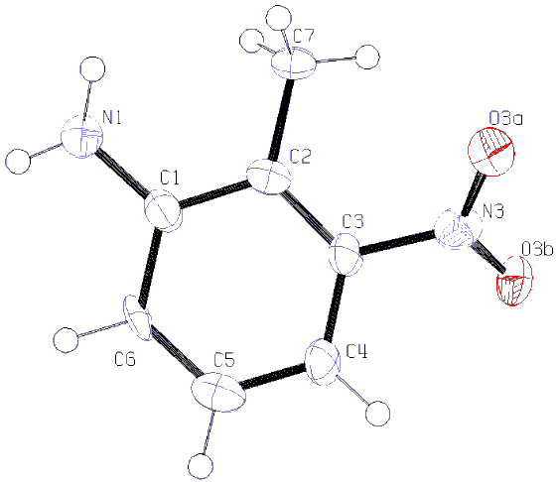
Table 1. Crystal data and structure refinement details.

Identification code 06skc0010p212121
Empirical formula C₇H₈N₂O₂
Formula weight 152.15
Temperature 120(2) K
Wavelength 0.71073 Å
Crystal system Orthorhombic
Space group P212121
Unit cell dimensions a = 3.8043(11) Å α = 90°
b = 12.987(4) Å β = 90°
c = 14.401(3) Å γ = 90°
Volume 711.5(3) Å³
Z 4
Density (calculated) 1.420 Mg / m³
Absorption coefficient 0.107 mm⁻¹
F(000) 320
Crystal plate; yellow
Crystal size 0.09 × 0.08 × 0.01 mm³
θ range for data collection 3.14 − 27.47°
Index ranges −4 ≤ h ≤ 4, −16 ≤ k ≤ 16, −18 ≤ l ≤ 18
Reflections collected 8327
Independent reflections 985 [R_{int} = 0.3099]
Completeness to θ = 27.47° 99.5 %
Absorption correction Semi−empirical from equivalents
Max. and min. transmission 0.9989 and 0.9905
Refinement method Full-matrix least-squares on F²
Data / restraints / parameters 985 / 2 / 107
Goodness-of-fit on F² 1.158
Final R indices [F² > 2σ(F²)] R1 = 0.1223, wR2 = 0.1605
R indices (all data) R1 = 0.2282, wR2 = 0.1960
Absolute structure parameter −10(10)
Largest diff. peak and hole 0.328 and −0.473 e Å⁻³

Diffractometer: Nonius KappaCCD area detector (φ scans and ω scans to fill asymmetric unit). Cell determination: DirAx (Duisenberg, A.J.M.(1992). J. Appl. Cryst. 25, 92-96.) Data collection: Collect (Collect: Data collection software, R. Hooft, Nonius B.V., 1998). Data reduction and cell refinement: Denzo (Z. Otwinowski & W. Minor, Methods in Enzymology (1997) Vol. 276: Macromolecular Crystallography, part A, pp. 307−326; C. W. Carter, Jr. & R. M. Sweet, Eds., Academic Press). Absorption correction: Sheldrick, G. M. SADABS - Bruker Nonius area detector scaling and absorption correction - V2.10 Structure solution: SHELXS97 (G. M. Sheldrick, Acta Cryst. (1990) A46 467−473). Structure refinement: SHELXL97 (G. M. Sheldrick (1997), University of Göttingen, Germany). Graphics: ORTEP-3 (L.G. Farrugia, J. Appl. Cryst. (1997) 30, 565).

Special details:
All hydrogens except amine hydrogens fixed using a riding model. The position of the amine hydrogens and their thermal parameters were left to refine while their N-H distances were fixed at standard values.
As the crystals were very small and weakly diffracting, the R_{int} is higher than usual and there is a lower C-C bond precision. In spite of this the data are perfectly fine for viewing the gross connectivity and interactions in the structure.
Merge 4 was used as there are no heavy atoms in the structure.
Table 2. Atomic coordinates [× 10⁴], equivalent isotropic displacement parameters [Å² × 10³] and site occupancy factors. U_{eq} is defined as one third of the trace of the orthogonalized U^{ij} tensor.

Atom x y z U_{eq} S.o.f.

C1 −270(30) 4131(7) 4371(6) 30(3) 1
C2 890(20) 4762(7) 3644(6) 24(2) 1
C3 610(30) 5817(7) 3785(6) 30(3) 1
C4 −550(30) 6252(7) 4612(6) 30(2) 1
C5 −1590(30) 5609(8) 5309(7) 35(3) 1
C6 −1470(20) 4559(7) 5197(6) 26(2) 1
C7 2410(20) 4294(6) 2778(6) 27(2) 1
N1 −10(20) 3060(6) 4282(5) 28(2) 1
N3 1430(20) 6546(6) 3049(5) 33(2) 1
O3A 370(20) 6349(5) 2261(4) 43(2) 1
O3B 3101(19) 7329(5) 3254(5) 40(2) 1
Table 3. Bond lengths [Å] and angles [°].

C1−C6 1.389(11)
C1−C2 1.400(11)
C1−N1 1.401(12)
C2−C3 1.389(11)
C2−C7 1.504(11)
C3−C4 1.388(12)
C3−N3 1.456(11)
C4−C5 1.364(12)
C4−H4 0.9500
C5−C6 1.374(12)
C5−H5 0.9500
C6−H6 0.9500
C7−H7A 0.9800
C7−H7B 0.9800
C7−H7C 0.9800
N1−H1A 0.87(2)
N1−H1B 0.88(2)
N3−O3A 1.231(9)
N3−O3B 1.236(9)

C6−C1−C2 120.6(8)
C6−C1−N1 120.0(9)
C2−C1−N1 119.3(9)
C3−C2−C1 116.3(8)
C3−C2−C7 123.3(8)
C1−C2−C7 120.3(8)
C4−C3−C2 123.4(9)
C4−C3−N3 115.3(8)
C2−C3−N3 121.2(8)
C5−C4−C3 118.3(9)
C5−C4−H4 120.9
C3−C4−H4 120.9
C4−C5−C6 120.7(9)
C4−C5−H5 119.6
C6−C5−H5 119.6
C5−C6−C1 120.5(9)
C5−C6−H6 119.7
C1−C6−H6 119.7
C2−C7−H7A 109.5
C2−C7−H7B 109.5
H7A−C7−H7B 109.5
C2−C7−H7C 109.5
H7A−C7−H7C 109.5
H7B−C7−H7C 109.5
C1−N1−H1A 112(7)
C1−N1−H1B 119(6)
H1A−N1−H1B 116(10)
O3A−N3−O3B 124.1(8)
O3A−N3−C3 117.7(8)
O3B−N3−C3 118.2(8)

Symmetry transformations used to generate equivalent atoms:

Table 4. Anisotropic displacement parameters [Å²× 10³]. The anisotropic displacement
factor exponent takes the form: −2π ²[h²a*²U¹¹ + ... + 2 h k a* b* U¹² ].

Atom U¹¹ U²² U³³ U²³ U¹³ U¹²

C1 35(7) 34(6) 22(5) 3(5) 2(5) −7(5)
C2 18(5) 34(6) 20(5) −4(4) −6(4) 1(5)
C3 39(7) 26(6) 25(5) 9(4) 2(5) 10(5)
C4 33(6) 29(6) 28(5) 10(4) −3(5) 7(5)
C5 27(6) 49(7) 29(6) −9(5) 3(5) 0(5)
C6 33(6) 34(6) 12(5) 13(4) −1(4) −5(5)
C7 29(6) 31(6) 22(5) −8(4) −3(4) −2(5)
N1 27(5) 31(5) 24(5) 0(4) −10(4) −5(4)
N3 34(5) 33(5) 32(5) −6(4) −9(4) 0(5)
O3A 60(5) 37(4) 33(4) 3(4) 0(4) 0(4)
O3B 51(5) 25(4) 45(4) 8(4) 9(4) −8(4)
Table 5. Hydrogen bonds [Å and °].

D−H···A d(D−H) d(H···A) d(D···A) ∠(DHA)

N1−H1A...N1^{i} 0.87(2) 2.30(3) 3.165(12) 173(9)
N1−H1B...O3A^{ii} 0.88(2) 2.35(5) 3.145(10) 151(8)
Symmetry transformations used to generate equivalent atoms:
(i) x−1/2,−y+1/2,−z+1 (ii) −x,y−1/2,−z+1/2

