 | University of Southampton · Department of Chemistry  EPSRC National Crystallography Service | 

Table 1. Crystal data and structure refinement.
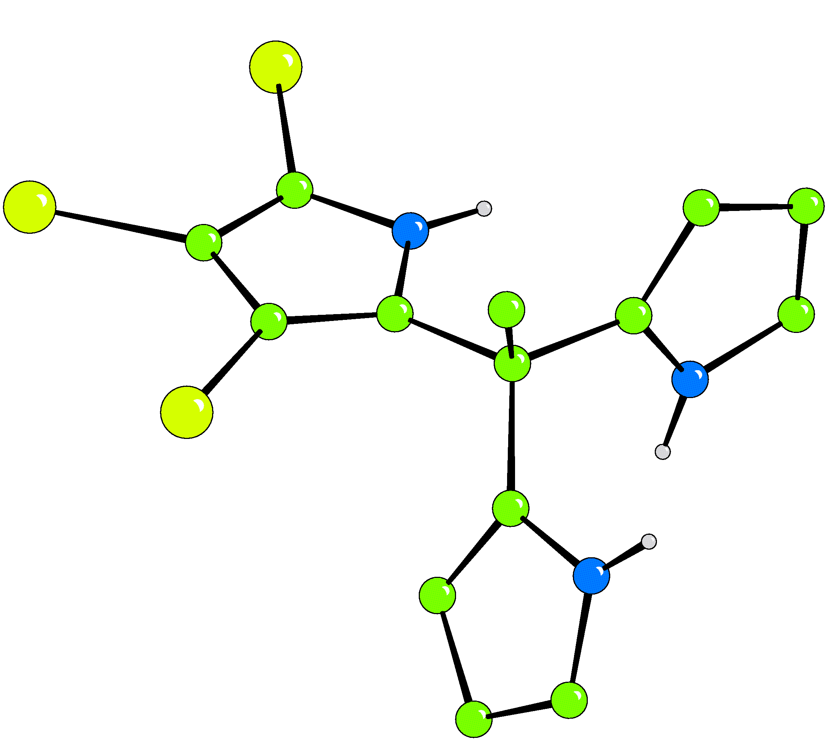
Identification code 03SOT024
Empirical formula C₁₄H₁₂Br₃N₃
Formula weight 462.00
Temperature 120(2) K
Wavelength 0.71073 Å
Crystal system Monoclinic
Space group P2₁/c
Unit cell dimensions a = 17.13(4) Å
b = 10.965(8) Å β = 114.25(7)°
c = 17.450(15) Å
Volume 2989(7) Å³
Z 8
Density (calculated) 2.053 Mg / m³
Absorption coefficient 8.090 mm⁻¹
F(000) 1776
Crystal Colourless Needle
Crystal size 0.10 × 0.03 × 0.03 mm³
θ range for data collection 4.90 − 25.03°
Index ranges −19 ≤ h ≤ 20, −13 ≤ k ≤ 13, −19 ≤ l ≤ 19
Reflections collected 13791
Independent reflections 3468 [R_{int} = 0.0742]
Completeness to θ = 25.03° 65.7 %
Absorption correction Semi−empirical from equivalents
Max. and min. transmission 0.7934 and 0.4984
Refinement method Full-matrix least-squares on F²
Data / restraints / parameters 3468 / 0 / 364
Goodness-of-fit on F² 1.043
Final R indices [F² > 2σ(F²)] R1 = 0.0480, wR2 = 0.0952
R indices (all data) R1 = 0.0915, wR2 = 0.1081
Extinction coefficient 0.00032(17)
Largest diff. peak and hole 0.626 and −0.835 e Å⁻³

Diffractometer: Nonius KappaCCD area detector (φ scans and ω scans to fill asymmetric unit sphere). Cell determination: DirAx (Duisenberg, A.J.M.(1992). J. Appl. Cryst. 25, 92-96.) Data collection: Collect (Collect: Data collection software, R. Hooft, Nonius B.V., 1998). Data reduction and cell refinement: Denzo (Z. Otwinowski & W. Minor, Methods in Enzymology (1997) Vol. 276: Macromolecular Crystallography, part A, pp. 307−326; C. W. Carter, Jr. & R. M. Sweet, Eds., Academic Press). Absorption correction: SORTAV (R. H. Blessing, Acta Cryst. A51 (1995) 33−37; R. H. Blessing, J. Appl. Cryst. 30 (1997) 421−426). Structure solution: SHELXS97 (G. M. Sheldrick, Acta Cryst. (1990) A46 467−473). Structure refinement: SHELXL97 (G. M. Sheldrick (1997), University of Göttingen, Germany). Graphics: Cameron - A Molecular Graphics Package. (D. M. Watkin, L. Pearce and C. K. Prout, Chemical Crystallography Laboratory, University of Oxford, 1993).

Special details: All hydrogen atoms were placed in idealised positions and refined using a riding model. The crystal was a twin – 180 degrees around c (direct)
Table 2. Atomic coordinates [× 10⁴], equivalent isotropic displacement parameters [Å² × 10³] and site occupancy factors. U_{eq} is defined as one third of the trace of the orthogonalized U^{ij} tensor.

Atom x y z U_{eq} S.o.f.

Br1 925(1) −940(1) −380(1) 44(1) 1
Br2 917(1) −3881(1) 602(1) 39(1) 1
Br3 1353(1) −3237(1) 2750(1) 30(1) 1
N1 1236(4) −354(6) 1292(4) 18(2) 1
N2 2206(5) −175(7) 4356(5) 44(2) 1
N3 2358(4) 1743(5) 2742(4) 21(2) 1
C1 1090(5) −1256(8) 712(5) 27(2) 1
C2 1107(5) −2338(7) 1109(5) 21(2) 1
C3 1272(5) −2060(6) 1943(5) 17(2) 1
C4 1348(5) −818(7) 2051(5) 20(2) 1
C5 1436(5) −10(7) 2781(5) 20(2) 1
C6 584(5) −138(7) 2881(5) 27(2) 1
C7 2169(5) −438(7) 3573(5) 22(2) 1
C8 2911(8) −689(10) 4948(7) 59(3) 1
C9 3319(6) −1300(8) 4569(7) 51(3) 1
C10 2863(5) −1129(7) 3669(6) 30(2) 1
C11 1563(5) 1300(7) 2602(5) 17(2) 1
C12 990(6) 2245(7) 2283(5) 24(2) 1
C13 1467(6) 3274(7) 2250(5) 24(2) 1
C14 2294(7) 2944(7) 2522(5) 25(2) 1
Br4 3217(1) −785(1) 1502(1) 48(1) 1
Br5 5311(1) −863(1) 3146(1) 33(1) 1
Br6 6632(1) 1161(1) 2531(1) 32(1) 1
N4 4986(4) 1328(5) 1199(4) 20(2) 1
N5 1970(4) 1852(6) −695(4) 22(2) 1
N6 3897(4) 3235(6) −348(4) 23(2) 1
C15 5454(5) 865(7) 1968(5) 20(2) 1
C16 4955(5) 109(7) 2190(5) 23(2) 1
C17 4135(5) 145(7) 1521(5) 20(2) 1
C18 4157(5) 880(6) 916(5) 17(2) 1
C19 3509(5) 1157(6) 16(5) 18(2) 1
C20 3283(5) −59(7) −463(5) 26(2) 1
C21 2711(5) 1734(7) 31(5) 22(2) 1
C22 2546(6) 2195(8) 677(6) 32(2) 1
C23 1673(6) 2586(8) 332(5) 29(2) 1
C24 1357(5) 2349(7) −516(5) 25(2) 1
C25 3918(5) 2007(6) −409(5) 19(2) 1
C26 4364(5) 1731(7) −870(5) 21(2) 1
C27 4616(5) 2847(7) −1118(5) 29(2) 1
C28 4315(5) 3761(7) −785(5) 25(2) 1
Table 3. Bond lengths [Å] and angles [°].

Br1−C1 1.840(9)
Br2−C2 1.874(7)
Br3−C3 1.873(7)
N1−C4 1.357(10)
N1−C1 1.363(10)
N2−C8 1.349(13)
N2−C7 1.372(10)
N3−C14 1.363(10)
N3−C11 1.369(10)
C1−C2 1.369(10)
C2−C3 1.397(10)
C3−C4 1.374(10)
C4−C5 1.506(11)
C5−C11 1.505(10)
C5−C7 1.511(10)
C5−C6 1.547(11)
C7−C10 1.360(11)
C8−C9 1.323(15)
C9−C10 1.450(13)
C11−C12 1.378(10)
C12−C13 1.408(11)
C13−C14 1.347(12)
Br4−C17 1.864(8)
Br5−C16 1.859(8)
Br6−C15 1.874(9)
N4−C15 1.347(9)
N4−C18 1.388(10)
N5−C24 1.328(10)
N5−C21 1.383(10)
N6−C25 1.352(9)
N6−C28 1.371(10)
C15−C16 1.357(10)
C16−C17 1.411(11)
C17−C18 1.340(10)
C18−C19 1.536(11)
C19−C21 1.517(11)
C19−C25 1.527(10)
C19−C20 1.537(10)
C21−C22 1.367(11)
C22−C23 1.429(12)
C23−C24 1.376(11)
C25−C26 1.353(10)
C26−C27 1.424(11)
C27−C28 1.362(11)

C4−N1−C1 111.3(7)
C8−N2−C7 109.6(9)
C14−N3−C11 109.5(7)
N1−C1−C2 107.0(7)
N1−C1−Br1 122.4(6)
C2−C1−Br1 130.6(6)
C1−C2−C3 106.9(6)
C1−C2−Br2 125.4(6)
C3−C2−Br2 127.7(6)
C4−C3−C2 109.1(7)
C4−C3−Br3 127.3(6)
C2−C3−Br3 123.6(5)
N1−C4−C3 105.6(7)
N1−C4−C5 122.0(7)
C3−C4−C5 132.1(8)
C11−C5−C4 111.0(7)
C11−C5−C7 110.4(6)
C4−C5−C7 110.3(6)
C11−C5−C6 109.5(6)
C4−C5−C6 105.8(6)
C7−C5−C6 109.7(7)
C10−C7−N2 108.3(8)
C10−C7−C5 130.0(8)
N2−C7−C5 121.8(8)
C9−C8−N2 108.6(10)
C8−C9−C10 108.4(9)
C7−C10−C9 105.1(8)
N3−C11−C12 107.2(7)
N3−C11−C5 121.4(7)
C12−C11−C5 131.4(7)
C11−C12−C13 106.8(8)
C14−C13−C12 108.3(8)
C13−C14−N3 108.0(9)
C15−N4−C18 109.0(6)
C24−N5−C21 109.9(7)
C25−N6−C28 109.8(7)
N4−C15−C16 109.0(7)
N4−C15−Br6 122.0(6)
C16−C15−Br6 128.7(6)
C15−C16−C17 106.1(7)
C15−C16−Br5 126.4(6)
C17−C16−Br5 127.3(6)
C18−C17−C16 109.2(7)
C18−C17−Br4 127.6(6)
C16−C17−Br4 123.1(6)
C17−C18−N4 106.7(7)
C17−C18−C19 133.1(7)
N4−C18−C19 119.8(6)
C21−C19−C25 110.5(6)
C21−C19−C18 110.0(6)
C25−C19−C18 109.6(6)
C21−C19−C20 110.1(6)
C25−C19−C20 109.2(6)
C18−C19−C20 107.4(6)
C22−C21−N5 107.3(8)
C22−C21−C19 131.4(8)
N5−C21−C19 121.3(7)
C21−C22−C23 107.4(8)
C24−C23−C22 106.1(8)
N5−C24−C23 109.3(7)
N6−C25−C26 108.0(7)
N6−C25−C19 122.5(7)
C26−C25−C19 129.5(7)
C25−C26−C27 107.8(7)
C28−C27−C26 106.7(7)
C27−C28−N6 107.7(7)

Table 4. Anisotropic displacement parameters [Å²× 10³]. The anisotropic displacement
factor exponent takes the form: −2π ²[h²a*²U¹¹ + ... + 2 h k a* b* U¹² ].

Atom U¹¹ U²² U³³ U²³ U¹³ U¹²

Br1 54(1) 55(1) 19(1) −4(1) 10(1) −3(1)
Br2 46(1) 30(1) 45(1) −21(1) 22(1) −8(1)
Br3 36(1) 20(1) 41(1) 2(1) 22(1) −2(1)
N1 18(4) 22(4) 14(4) 3(3) 7(3) 0(3)
N2 39(5) 57(5) 34(5) 7(4) 14(4) −18(4)
N3 29(4) 20(4) 13(4) 8(3) 8(3) 9(3)
C1 24(5) 30(5) 26(5) −5(4) 9(4) −2(4)
C2 20(5) 17(4) 22(5) −6(4) 2(4) 4(4)
C3 12(4) 18(4) 16(5) −3(4) 2(4) −6(3)
C4 15(5) 28(5) 13(5) −3(4) 3(4) 3(4)
C5 18(5) 21(4) 21(5) −6(4) 9(4) −1(4)
C6 26(5) 23(5) 28(6) −5(4) 8(4) 3(4)
C7 33(5) 22(4) 10(5) −3(4) 9(4) −5(4)
C8 62(9) 60(8) 34(7) 16(6) −2(7) −30(7)
C9 27(6) 28(6) 62(8) 23(5) −19(6) −5(5)
C10 20(5) 17(4) 45(7) −7(4) 5(5) 3(4)
C11 20(5) 21(4) 9(4) −5(3) 5(4) 3(4)
C12 35(6) 17(4) 22(5) −8(4) 14(5) −3(4)
C13 46(6) 17(5) 9(5) −9(4) 12(5) 1(5)
C14 42(7) 17(5) 11(5) −2(4) 8(5) 0(4)
Br4 33(1) 68(1) 43(1) 23(1) 16(1) −7(1)
Br5 39(1) 36(1) 22(1) 12(1) 12(1) 7(1)
Br6 27(1) 35(1) 28(1) 1(1) 5(1) −3(1)
N4 29(4) 18(3) 19(4) 0(3) 16(4) 3(3)
N5 23(4) 36(4) 7(4) 15(3) 6(4) 5(4)
N6 28(4) 29(4) 15(4) −4(3) 12(3) 6(3)
C15 22(5) 20(4) 6(4) −1(4) −6(4) 1(4)
C16 31(5) 24(5) 16(5) 6(4) 11(4) 7(4)
C17 17(5) 23(4) 22(5) 4(4) 9(4) 0(4)
C18 21(5) 15(4) 16(5) 4(4) 10(4) 3(4)
C19 21(5) 15(4) 20(5) 4(4) 10(4) 3(4)
C20 19(5) 36(5) 21(5) 6(4) 6(4) 3(4)
C21 28(5) 24(4) 19(5) 11(4) 14(4) 6(4)
C22 29(6) 40(6) 28(6) −3(5) 14(5) −1(5)
C23 25(6) 43(6) 21(6) 7(5) 13(5) 13(5)
C24 11(5) 40(5) 24(6) 9(4) 6(4) 8(4)
C25 20(5) 16(4) 17(5) 2(4) 4(4) 1(4)
C26 21(5) 20(4) 21(5) −7(4) 8(4) 3(4)
C27 23(5) 40(5) 21(5) 0(4) 7(4) −2(4)
C28 21(5) 22(5) 29(6) 6(4) 6(4) −1(4)

Table 5. Hydrogen coordinates [× 10⁴] and isotropic displacement parameters [Å² × 10³].

Atom x y z U_{eq} S.o.f.

H1 1256 428 1188 21 1
H2 1827 262 4456 53 1
H3 2836 1319 2944 25 1
H6A 106 91 2354 40 1
H6B 593 399 3334 40 1
H6C 512 −985 3020 40 1
H8 3087 −623 5538 71 1
H9 3824 −1770 4840 61 1
H10 3016 −1434 3240 36 1
H12 389 2209 2118 28 1
H13 1243 4066 2068 29 1
H14 2754 3457 2555 29 1
H4 5175 1832 922 24 1
H5 1912 1630 −1200 27 1
H6 3651 3636 −70 28 1
H20A 3070 −633 −163 39 1
H20B 3795 −398 −502 39 1
H20C 2840 78 −1030 39 1
H22 2939 2247 1250 38 1
H23 1372 2938 629 34 1
H24 791 2515 −912 30 1
H26 4487 935 −1005 25 1
H27 4933 2937 −1452 34 1
H28 4384 4611 −844 31 1

Table 6. Hydrogen bonds [Å and °].

D−H···A d(D−H) d(H···A) d(D···A) ∠(DHA)

N6−H6...Br5^{i} 0.88 3.13 3.646(7) 119.3
N4−H4...N6^{i} 0.88 2.84 3.317(7) 115.4
N3−H3...N6^{i} 0.88 2.82 3.293(7) 114.9
Symmetry transformations used to generate equivalent atoms:
(i) −x+1,y+1/2,−z+1/2

