 | University of Southampton · Department of Chemistry  EPSRC National Crystallography Service | 

Table 1. Crystal data and structure refinement.
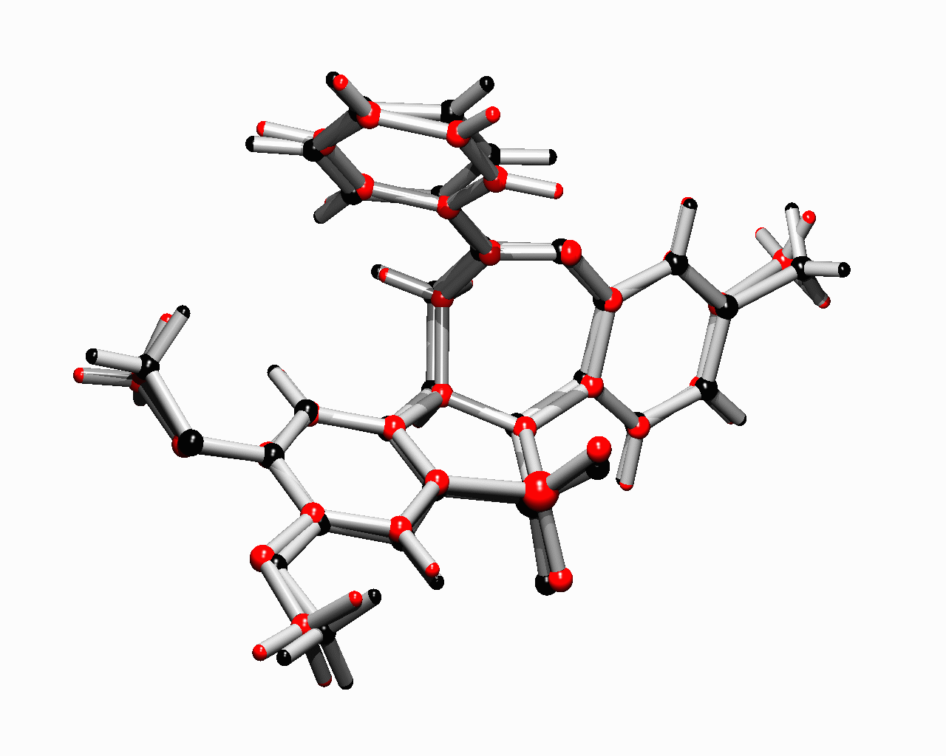
Identification code 03src0209 − JPB1
Empirical formula C₂₄H₂₂N₂O₄S
Formula weight 434.50
Temperature 120(2) K
Wavelength 0.71073 Å
Crystal system Triclinic
Space group P-1
Unit cell dimensions a = 11.9007(4) Å α = 109.852(2)°
b = 12.8521(4) Å β = 90.743(2)°
c = 14.6202(5) Å γ = 92.775(2)°
Volume 2099.76(12) Å³
Z 4
Density (calculated) 1.374 Mg / m³
Absorption coefficient 0.189 mm⁻¹
F(000) 912
Crystal Pale Yellow Prism
Crystal size 0.50 × 0.30 × 0.10 mm³
θ range for data collection 2.96 − 25.02°
Index ranges −14 ≤ h ≤ 14, −15 ≤ k ≤ 15, −17 ≤ l ≤ 17
Reflections collected 31054
Independent reflections 7393 [R_{int} = 0.0599]
Completeness to θ = 25.02° 99.6 %
Absorption correction Semi−empirical from equivalents
Max. and min. transmission 0.9814 and 0.9115
Refinement method Full-matrix least-squares on F²
Data / restraints / parameters 7393 / 0 / 566
Goodness-of-fit on F² 0.989
Final R indices [F² > 2σ(F²)] R1 = 0.0405, wR2 = 0.0973
R indices (all data) R1 = 0.0654, wR2 = 0.1080
Extinction coefficient 0.0052(7)
Largest diff. peak and hole 0.287 and −0.457 e Å⁻³

Diffractometer: Nonius KappaCCD area detector (φ scans and ω scans to fill asymmetric unit sphere). Cell determination: DirAx (Duisenberg, A.J.M.(1992). J. Appl. Cryst. 25, 92-96.) Data collection: Collect (Collect: Data collection software, R. Hooft, Nonius B.V., 1998). Data reduction and cell refinement: Denzo (Z. Otwinowski & W. Minor, Methods in Enzymology (1997) Vol. 276: Macromolecular Crystallography, part A, pp. 307−326; C. W. Carter, Jr. & R. M. Sweet, Eds., Academic Press). Absorption correction: SORTAV (R. H. Blessing, Acta Cryst. A51 (1995) 33−37; R. H. Blessing, J. Appl. Cryst. 30 (1997) 421−426). Structure solution: SHELXS97 (G. M. Sheldrick, Acta Cryst. (1990) A46 467−473). Structure refinement: SHELXL97 (G. M. Sheldrick (1997), University of Göttingen, Germany). Graphics: Cameron - A Molecular Graphics Package. (D. M. Watkin, L. Pearce and C. K. Prout, Chemical Crystallography Laboratory, University of Oxford, 1993).

Special details: All hydrogen atoms were placed in idealised positions and refined using a riding model. C9=R; C33=S
Table 2. Atomic coordinates [× 10⁴], equivalent isotropic displacement parameters [Å² × 10³] and site occupancy factors. U_{eq} is defined as one third of the trace of the orthogonalized U^{ij} tensor.

Atom x y z U_{eq} S.o.f.

C1 3992(2) −2363(2) 1428(2) 36(1) 1
C2 4292(2) −507(2) −1372(2) 31(1) 1
C3 1698(2) 16(2) 1416(1) 19(1) 1
C4 2404(2) −817(2) 1418(2) 22(1) 1
C5 3235(2) −1095(2) 744(2) 23(1) 1
C6 3348(2) −569(2) 37(1) 22(1) 1
C7 2660(2) 266(2) 46(2) 22(1) 1
C8 1844(2) 547(2) 755(1) 20(1) 1
C9 702(2) 357(2) 2053(1) 20(1) 1
C10 979(2) 759(2) 3145(1) 21(1) 1
C11 1669(2) 1849(2) 3465(1) 19(1) 1
C12 2905(2) 1897(2) 3658(1) 21(1) 1
C13 3460(2) 1009(2) 3745(2) 27(1) 1
C14 4622(2) 1095(2) 3914(2) 31(1) 1
C15 5237(2) 2056(2) 3991(2) 32(1) 1
C16 4692(2) 2948(2) 3910(2) 33(1) 1
C17 3540(2) 2873(2) 3751(2) 27(1) 1
C18 −423(2) 2069(2) 2433(1) 21(1) 1
C19 −1528(2) 2199(2) 2206(2) 25(1) 1
C20 −2159(2) 2991(2) 2840(2) 26(1) 1
C21 −1698(2) 3680(2) 3733(2) 24(1) 1
C22 −578(2) 3563(2) 3945(2) 24(1) 1
C23 70(2) 2778(2) 3321(2) 21(1) 1
C24 −2385(2) 4518(2) 4447(2) 31(1) 1
N1 209(1) 1241(1) 1764(1) 21(1) 1
N2 1221(1) 2771(1) 3569(1) 22(1) 1
O1 4000(1) −1868(1) 685(1) 29(1) 1
O2 4170(1) −960(1) −613(1) 28(1) 1
O3 1347(1) 2649(1) 1245(1) 28(1) 1
O4 150(1) 1289(1) 29(1) 26(1) 1
S1 854(1) 1536(1) 884(1) 20(1) 1
C25 4183(2) 3022(2) 1354(2) 39(1) 1
C26 6495(2) 6780(2) 3526(2) 35(1) 1
C27 2352(2) 5705(2) 2954(1) 19(1) 1
C28 2926(2) 4762(2) 2485(2) 22(1) 1
C29 4092(2) 4831(2) 2518(1) 23(1) 1
C30 4697(2) 5830(2) 3063(1) 22(1) 1
C31 4132(2) 6760(2) 3524(1) 21(1) 1
C32 2959(2) 6677(2) 3446(1) 19(1) 1
C33 1087(2) 5782(2) 3026(1) 21(1) 1
C34 400(2) 5383(2) 2068(1) 20(1) 1
C35 648(2) 6090(2) 1444(1) 21(1) 1
C36 1331(2) 5684(2) 565(1) 22(1) 1
C37 1789(2) 4652(2) 264(2) 31(1) 1
C38 2498(2) 4349(2) −516(2) 40(1) 1
C39 2754(2) 5066(2) −1008(2) 42(1) 1
C40 2270(2) 6071(2) −745(2) 42(1) 1
C41 1557(2) 6378(2) 23(2) 32(1) 1
C42 −31(2) 7531(2) 3413(2) 21(1) 1
C43 −587(2) 8170(2) 4223(2) 28(1) 1
C44 −1430(2) 8831(2) 4131(2) 31(1) 1
C45 −1754(2) 8855(2) 3222(2) 29(1) 1
C46 −1184(2) 8218(2) 2416(2) 26(1) 1
C47 −315(2) 7561(2) 2492(2) 22(1) 1
C48 −2671(2) 9570(2) 3111(2) 43(1) 1
N3 929(1) 6971(1) 3561(1) 22(1) 1
N4 293(1) 7070(1) 1653(1) 24(1) 1
O5 4741(1) 3987(1) 2052(1) 31(1) 1
O6 5838(1) 5768(1) 3079(1) 29(1) 1
O7 2185(1) 8117(1) 5014(1) 32(1) 1
O8 2197(1) 8601(1) 3549(1) 33(1) 1
S2 2087(1) 7744(1) 3973(1) 22(1) 1
Table 3. Bond lengths [Å] and angles [°].

C1−O1 1.433(2)
C2−O2 1.424(2)
C3−C8 1.367(3)
C3−C4 1.394(3)
C3−C9 1.505(3)
C4−C5 1.378(3)
C5−O1 1.362(2)
C5−C6 1.418(3)
C6−O2 1.364(2)
C6−C7 1.378(3)
C7−C8 1.398(3)
C8−S1 1.740(2)
C9−N1 1.482(2)
C9−C10 1.528(3)
C10−C11 1.514(3)
C11−N2 1.286(2)
C11−C12 1.488(3)
C12−C13 1.389(3)
C12−C17 1.397(3)
C13−C14 1.393(3)
C14−C15 1.374(3)
C15−C16 1.383(3)
C16−C17 1.381(3)
C18−C19 1.384(3)
C18−C23 1.408(3)
C18−N1 1.430(3)
C19−C20 1.382(3)
C20−C21 1.392(3)
C21−C22 1.391(3)
C21−C24 1.504(3)
C22−C23 1.384(3)
C23−N2 1.413(3)
N1−S1 1.6479(16)
O3−S1 1.4373(14)
O4−S1 1.4294(14)
C25−O5 1.437(3)
C26−O6 1.429(3)
C27−C32 1.374(3)
C27−C28 1.390(3)
C27−C33 1.517(3)
C28−C29 1.385(3)
C29−O5 1.354(2)
C29−C30 1.415(3)
C30−O6 1.365(2)
C30−C31 1.370(3)
C31−C32 1.395(3)
C32−S2 1.730(2)
C33−N3 1.484(3)
C33−C34 1.528(3)
C34−C35 1.512(3)
C35−N4 1.285(3)
C35−C36 1.482(3)
C36−C37 1.388(3)
C36−C41 1.399(3)
C37−C38 1.386(3)
C38−C39 1.374(3)
C39−C40 1.374(4)
C40−C41 1.376(3)
C42−C43 1.388(3)
C42−C47 1.398(3)
C42−N3 1.432(3)
C43−C44 1.380(3)
C44−C45 1.390(3)
C45−C46 1.392(3)
C45−C48 1.503(3)
C46−C47 1.393(3)
C47−N4 1.402(3)
N3−S2 1.6406(17)
O7−S2 1.4321(15)
O8−S2 1.4382(15)

C8−C3−C4 119.81(19)
C8−C3−C9 114.71(17)
C4−C3−C9 125.35(17)
C5−C4−C3 118.93(18)
O1−C5−C4 124.85(18)
O1−C5−C6 114.49(18)
C4−C5−C6 120.65(18)
O2−C6−C7 125.26(18)
O2−C6−C5 114.50(17)
C7−C6−C5 120.24(18)
C6−C7−C8 117.62(18)
C3−C8−C7 122.65(18)
C3−C8−S1 111.37(15)
C7−C8−S1 125.91(15)
N1−C9−C3 105.11(15)
N1−C9−C10 111.04(15)
C3−C9−C10 114.78(16)
C11−C10−C9 111.24(15)
N2−C11−C12 117.01(17)
N2−C11−C10 121.74(17)
C12−C11−C10 121.24(17)
C13−C12−C17 118.27(19)
C13−C12−C11 122.75(18)
C17−C12−C11 118.98(18)
C12−C13−C14 120.3(2)
C15−C14−C13 120.8(2)
C14−C15−C16 119.4(2)
C17−C16−C15 120.3(2)
C16−C17−C12 120.9(2)
C19−C18−C23 118.92(19)
C19−C18−N1 120.14(18)
C23−C18−N1 120.92(17)
C20−C19−C18 121.33(19)
C19−C20−C21 120.70(19)
C22−C21−C20 117.60(19)
C22−C21−C24 120.97(19)
C20−C21−C24 121.42(18)
C23−C22−C21 122.68(19)
C22−C23−C18 118.72(18)
C22−C23−N2 118.58(17)
C18−C23−N2 122.55(18)
C18−N1−C9 120.90(15)
C18−N1−S1 118.90(13)
C9−N1−S1 115.15(13)
C11−N2−C23 120.08(16)
C5−O1−C1 117.25(16)
C6−O2−C2 117.44(16)
O4−S1−O3 114.71(8)
O4−S1−N1 112.29(8)
O3−S1−N1 110.02(8)
O4−S1−C8 111.82(9)
O3−S1−C8 112.54(9)
N1−S1−C8 93.60(9)
C32−C27−C28 119.01(18)
C32−C27−C33 114.27(17)
C28−C27−C33 126.66(17)
C29−C28−C27 119.11(18)
O5−C29−C28 124.52(18)
O5−C29−C30 114.72(17)
C28−C29−C30 120.76(18)
O6−C30−C31 125.14(18)
O6−C30−C29 114.80(17)
C31−C30−C29 120.05(18)
C30−C31−C32 117.86(18)
C27−C32−C31 123.10(18)
C27−C32−S2 111.57(15)
C31−C32−S2 125.30(15)
N3−C33−C27 104.51(15)
N3−C33−C34 110.71(15)
C27−C33−C34 116.61(16)
C35−C34−C33 112.47(16)
N4−C35−C36 116.87(18)
N4−C35−C34 122.00(18)
C36−C35−C34 121.12(17)
C37−C36−C41 118.0(2)
C37−C36−C35 123.05(18)
C41−C36−C35 118.95(19)
C38−C37−C36 120.7(2)
C39−C38−C37 120.3(2)
C38−C39−C40 119.6(2)
C39−C40−C41 120.7(2)
C40−C41−C36 120.6(2)
C43−C42−C47 120.06(19)
C43−C42−N3 118.37(18)
C47−C42−N3 121.02(18)
C44−C43−C42 120.7(2)
C43−C44−C45 120.6(2)
C44−C45−C46 118.10(19)
C44−C45−C48 121.1(2)
C46−C45−C48 120.7(2)
C45−C46−C47 122.4(2)
C46−C47−C42 118.06(19)
C46−C47−N4 117.26(18)
C42−C47−N4 124.33(18)
C42−N3−C33 123.39(16)
C42−N3−S2 116.39(13)
C33−N3−S2 115.49(13)
C35−N4−C47 121.94(17)
C29−O5−C25 116.94(16)
C30−O6−C26 117.06(16)
O7−S2−O8 115.29(9)
O7−S2−N3 111.88(9)
O8−S2−N3 110.19(9)
O7−S2−C32 111.59(9)
O8−S2−C32 112.07(9)
N3−S2−C32 93.86(9)

Table 4. Anisotropic displacement parameters [Å²× 10³]. The anisotropic displacement
factor exponent takes the form: −2π ²[h²a*²U¹¹ + ... + 2 h k a* b* U¹² ].

Atom U¹¹ U²² U³³ U²³ U¹³ U¹²

C1 38(1) 36(1) 43(2) 25(1) 3(1) 12(1)
C2 32(1) 39(1) 25(1) 13(1) 6(1) 4(1)
C3 22(1) 14(1) 17(1) 2(1) −3(1) −2(1)
C4 27(1) 18(1) 21(1) 9(1) −2(1) 0(1)
C5 24(1) 17(1) 26(1) 6(1) 0(1) 4(1)
C6 22(1) 21(1) 18(1) 3(1) 0(1) 1(1)
C7 25(1) 22(1) 21(1) 9(1) 0(1) 0(1)
C8 22(1) 16(1) 20(1) 4(1) −3(1) −2(1)
C9 21(1) 17(1) 21(1) 6(1) −1(1) 1(1)
C10 22(1) 21(1) 20(1) 6(1) 0(1) 2(1)
C11 23(1) 20(1) 14(1) 4(1) 0(1) 1(1)
C12 24(1) 24(1) 13(1) 3(1) 0(1) 2(1)
C13 26(1) 24(1) 27(1) 6(1) 1(1) 4(1)
C14 30(1) 34(1) 27(1) 7(1) −1(1) 12(1)
C15 23(1) 48(2) 24(1) 11(1) 0(1) 3(1)
C16 24(1) 40(1) 39(1) 18(1) −5(1) −6(1)
C17 25(1) 28(1) 31(1) 12(1) −3(1) 2(1)
C18 21(1) 18(1) 22(1) 6(1) 2(1) 3(1)
C19 23(1) 27(1) 23(1) 5(1) −3(1) 1(1)
C20 18(1) 31(1) 29(1) 9(1) −1(1) 4(1)
C21 24(1) 20(1) 27(1) 9(1) 2(1) 4(1)
C22 25(1) 20(1) 23(1) 4(1) −4(1) 1(1)
C23 22(1) 19(1) 24(1) 7(1) −1(1) 0(1)
C24 27(1) 31(1) 32(1) 7(1) 2(1) 7(1)
N1 23(1) 19(1) 20(1) 7(1) 0(1) 4(1)
N2 19(1) 22(1) 22(1) 4(1) −2(1) 2(1)
O1 34(1) 26(1) 32(1) 13(1) 5(1) 12(1)
O2 32(1) 30(1) 25(1) 11(1) 9(1) 10(1)
O3 32(1) 17(1) 33(1) 7(1) 0(1) −2(1)
O4 31(1) 27(1) 22(1) 8(1) −6(1) 2(1)
S1 22(1) 17(1) 21(1) 6(1) −1(1) 1(1)
C25 39(1) 26(1) 39(1) −6(1) −2(1) 7(1)
C26 24(1) 36(1) 40(1) 7(1) 0(1) −3(1)
C27 20(1) 20(1) 19(1) 10(1) −1(1) 1(1)
C28 23(1) 17(1) 24(1) 5(1) 0(1) 1(1)
C29 28(1) 20(1) 21(1) 6(1) 3(1) 8(1)
C30 19(1) 26(1) 20(1) 8(1) 1(1) 2(1)
C31 24(1) 18(1) 20(1) 6(1) −2(1) −2(1)
C32 23(1) 17(1) 19(1) 8(1) 2(1) 2(1)
C33 24(1) 16(1) 21(1) 6(1) 2(1) 3(1)
C34 18(1) 18(1) 21(1) 4(1) 1(1) 2(1)
C35 21(1) 22(1) 19(1) 5(1) −4(1) −1(1)
C36 24(1) 22(1) 19(1) 4(1) −1(1) 0(1)
C37 37(1) 30(1) 24(1) 7(1) 4(1) 4(1)
C38 44(2) 39(1) 31(1) 2(1) 10(1) 12(1)
C39 43(2) 54(2) 23(1) 5(1) 11(1) 1(1)
C40 56(2) 44(2) 27(1) 14(1) 8(1) −2(1)
C41 41(1) 31(1) 24(1) 9(1) 1(1) 1(1)
C42 18(1) 19(1) 25(1) 7(1) 2(1) 2(1)
C43 26(1) 30(1) 25(1) 6(1) 2(1) 4(1)
C44 26(1) 28(1) 33(1) 2(1) 8(1) 9(1)
C45 23(1) 21(1) 39(1) 6(1) −3(1) 4(1)
C46 26(1) 22(1) 30(1) 8(1) −6(1) 1(1)
C47 22(1) 18(1) 25(1) 5(1) 0(1) 0(1)
C48 35(1) 37(1) 52(2) 6(1) −7(1) 13(1)
N3 22(1) 18(1) 22(1) 4(1) −2(1) 3(1)
N4 26(1) 22(1) 21(1) 7(1) −1(1) 2(1)
O5 25(1) 24(1) 37(1) 0(1) 2(1) 8(1)
O6 20(1) 30(1) 31(1) 3(1) 0(1) 0(1)
O7 33(1) 34(1) 21(1) −2(1) −5(1) 7(1)
O8 33(1) 21(1) 48(1) 17(1) −3(1) 3(1)
S2 23(1) 18(1) 23(1) 5(1) −2(1) 3(1)

Table 5. Hydrogen coordinates [× 10⁴] and isotropic displacement parameters [Å² × 10³].

Atom x y z U_{eq} S.o.f.

H1A 4094 −1782 2067 54 1
H1B 4606 −2868 1329 54 1
H1C 3271 −2778 1396 54 1
H2A 3605 −684 −1784 47 1
H2B 4933 −824 −1766 47 1
H2C 4423 299 −1089 47 1
H4 2314 −1188 1877 26 1
H7 2738 637 −413 27 1
H9 141 −288 1893 23 1
H10A 271 850 3505 25 1
H10B 1404 195 3303 25 1
H13 3046 338 3690 32 1
H14 4992 483 3976 37 1
H15 6030 2106 4100 38 1
H16 5112 3614 3963 40 1
H17 3173 3495 3705 33 1
H19 −1860 1734 1601 30 1
H20 −2914 3065 2665 31 1
H22 −245 4042 4543 28 1
H24A −2971 4754 4095 46 1
H24B −1895 5162 4820 46 1
H24C −2736 4185 4892 46 1
H25A 3709 2634 1693 58 1
H25B 4746 2526 987 58 1
H25C 3714 3246 905 58 1
H26A 6307 7317 3214 52 1
H26B 7296 6639 3452 52 1
H26C 6332 7079 4220 52 1
H28 2523 4079 2147 26 1
H31 4527 7439 3885 25 1
H33 811 5345 3437 25 1
H34A 568 4608 1700 24 1
H34B −411 5395 2210 24 1
H37 1614 4149 598 37 1
H38 2808 3642 −712 48 1
H39 3262 4868 −1528 50 1
H40 2429 6558 −1096 50 1
H41 1215 7068 187 38 1
H43 −384 8152 4848 33 1
H44 −1793 9274 4694 37 1
H46 −1396 8231 1791 32 1
H48A −2339 10215 2979 65 1
H48B −3090 9820 3713 65 1
H48C −3184 9143 2570 65 1

Table 6. Possible Hydrogen bonds [Å and °].

D−H···A d(D−H) d(H···A) d(D···A) ∠(DHA)

C28−H28...O3 0.95 2.27 3.204(2) 169.2
C34−H34A...O3 0.99 2.60 3.552(3) 161.9
C37−H37...O3 0.95 2.43 3.371(2) 170.5
C10−H10B...O8 0.99 2.43 3.408(3) 170.6
C13−H13...O8 0.95 2.35 3.294(3) 174.3
C4−H4...O8 0.95 2.55 3.451(2) 157.5

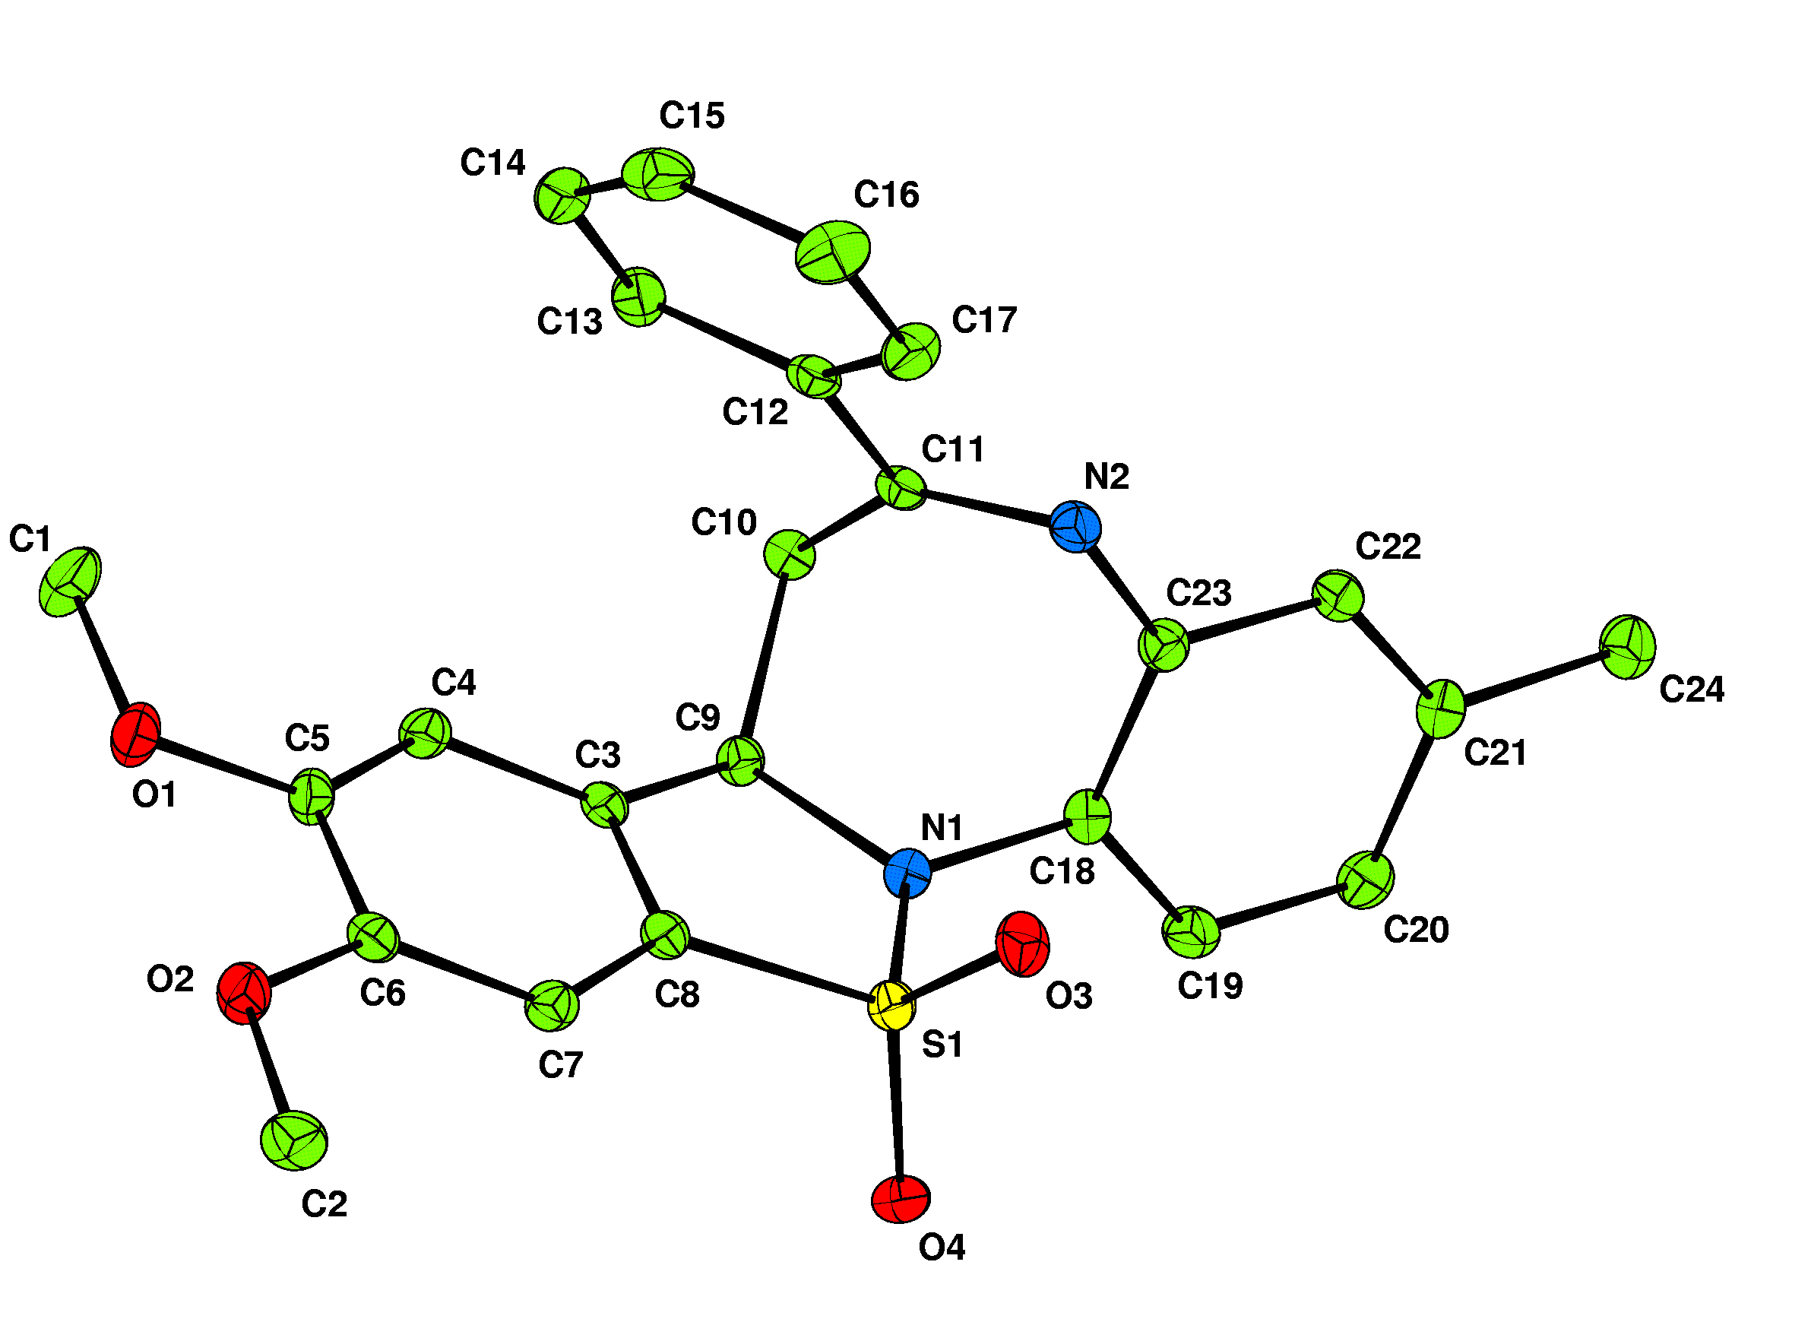

Molecule 1

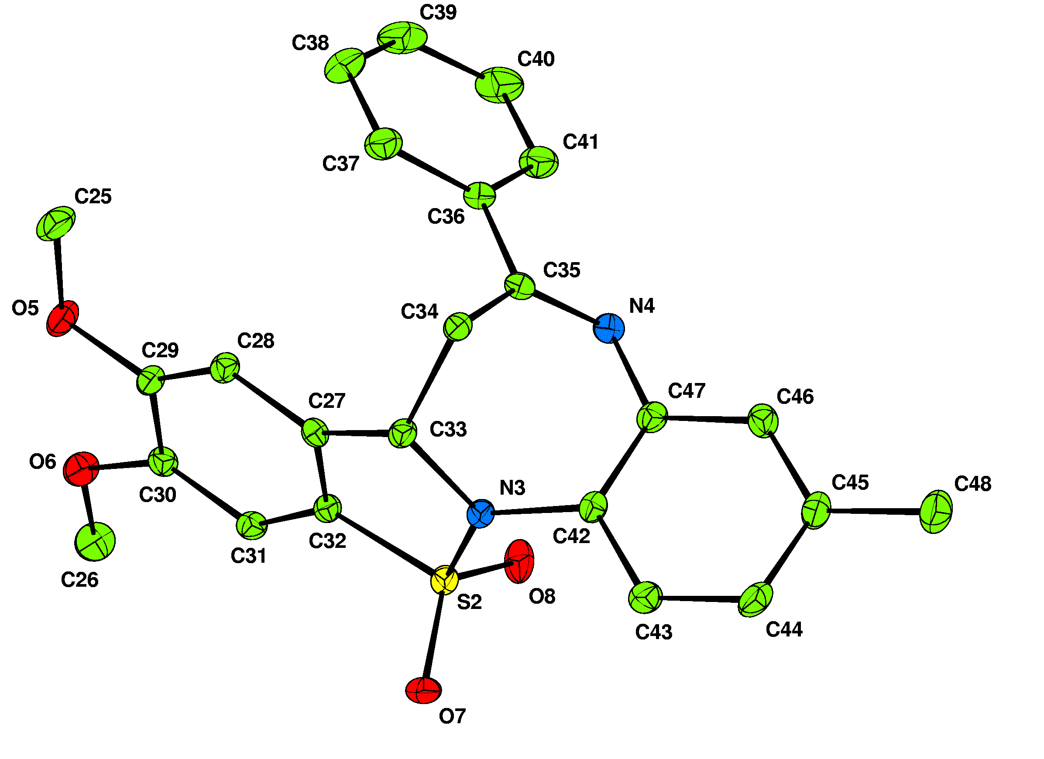

Molecule 2

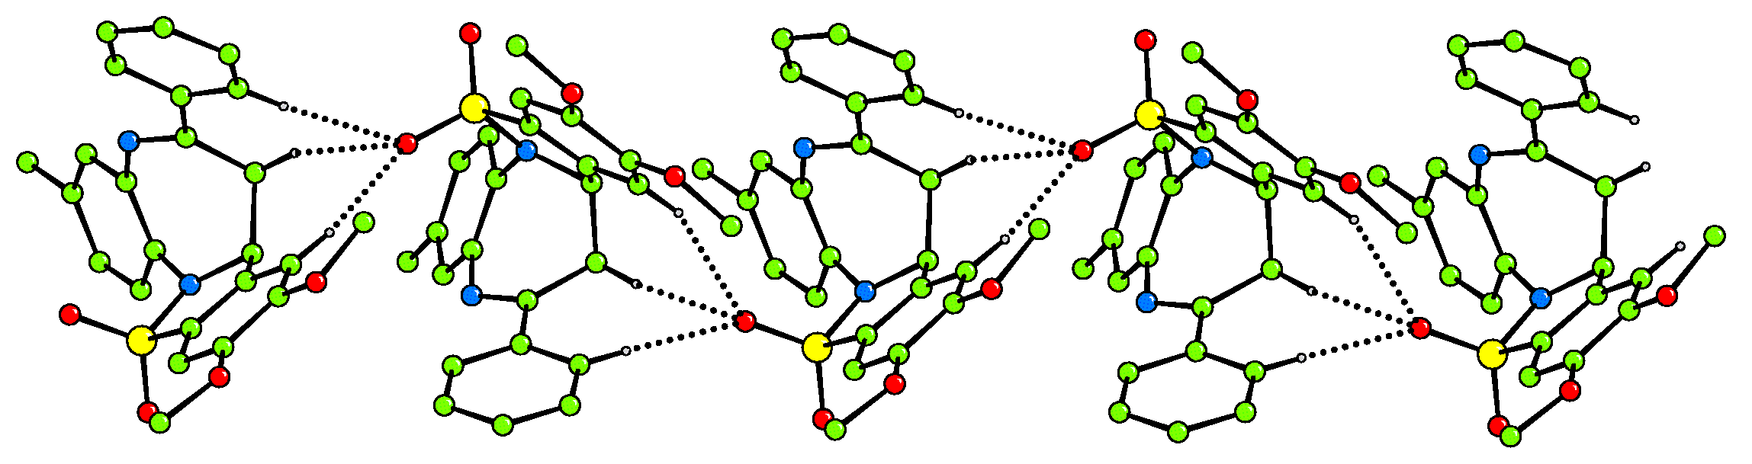

C-H…O hydrogen bonded chains extending along b

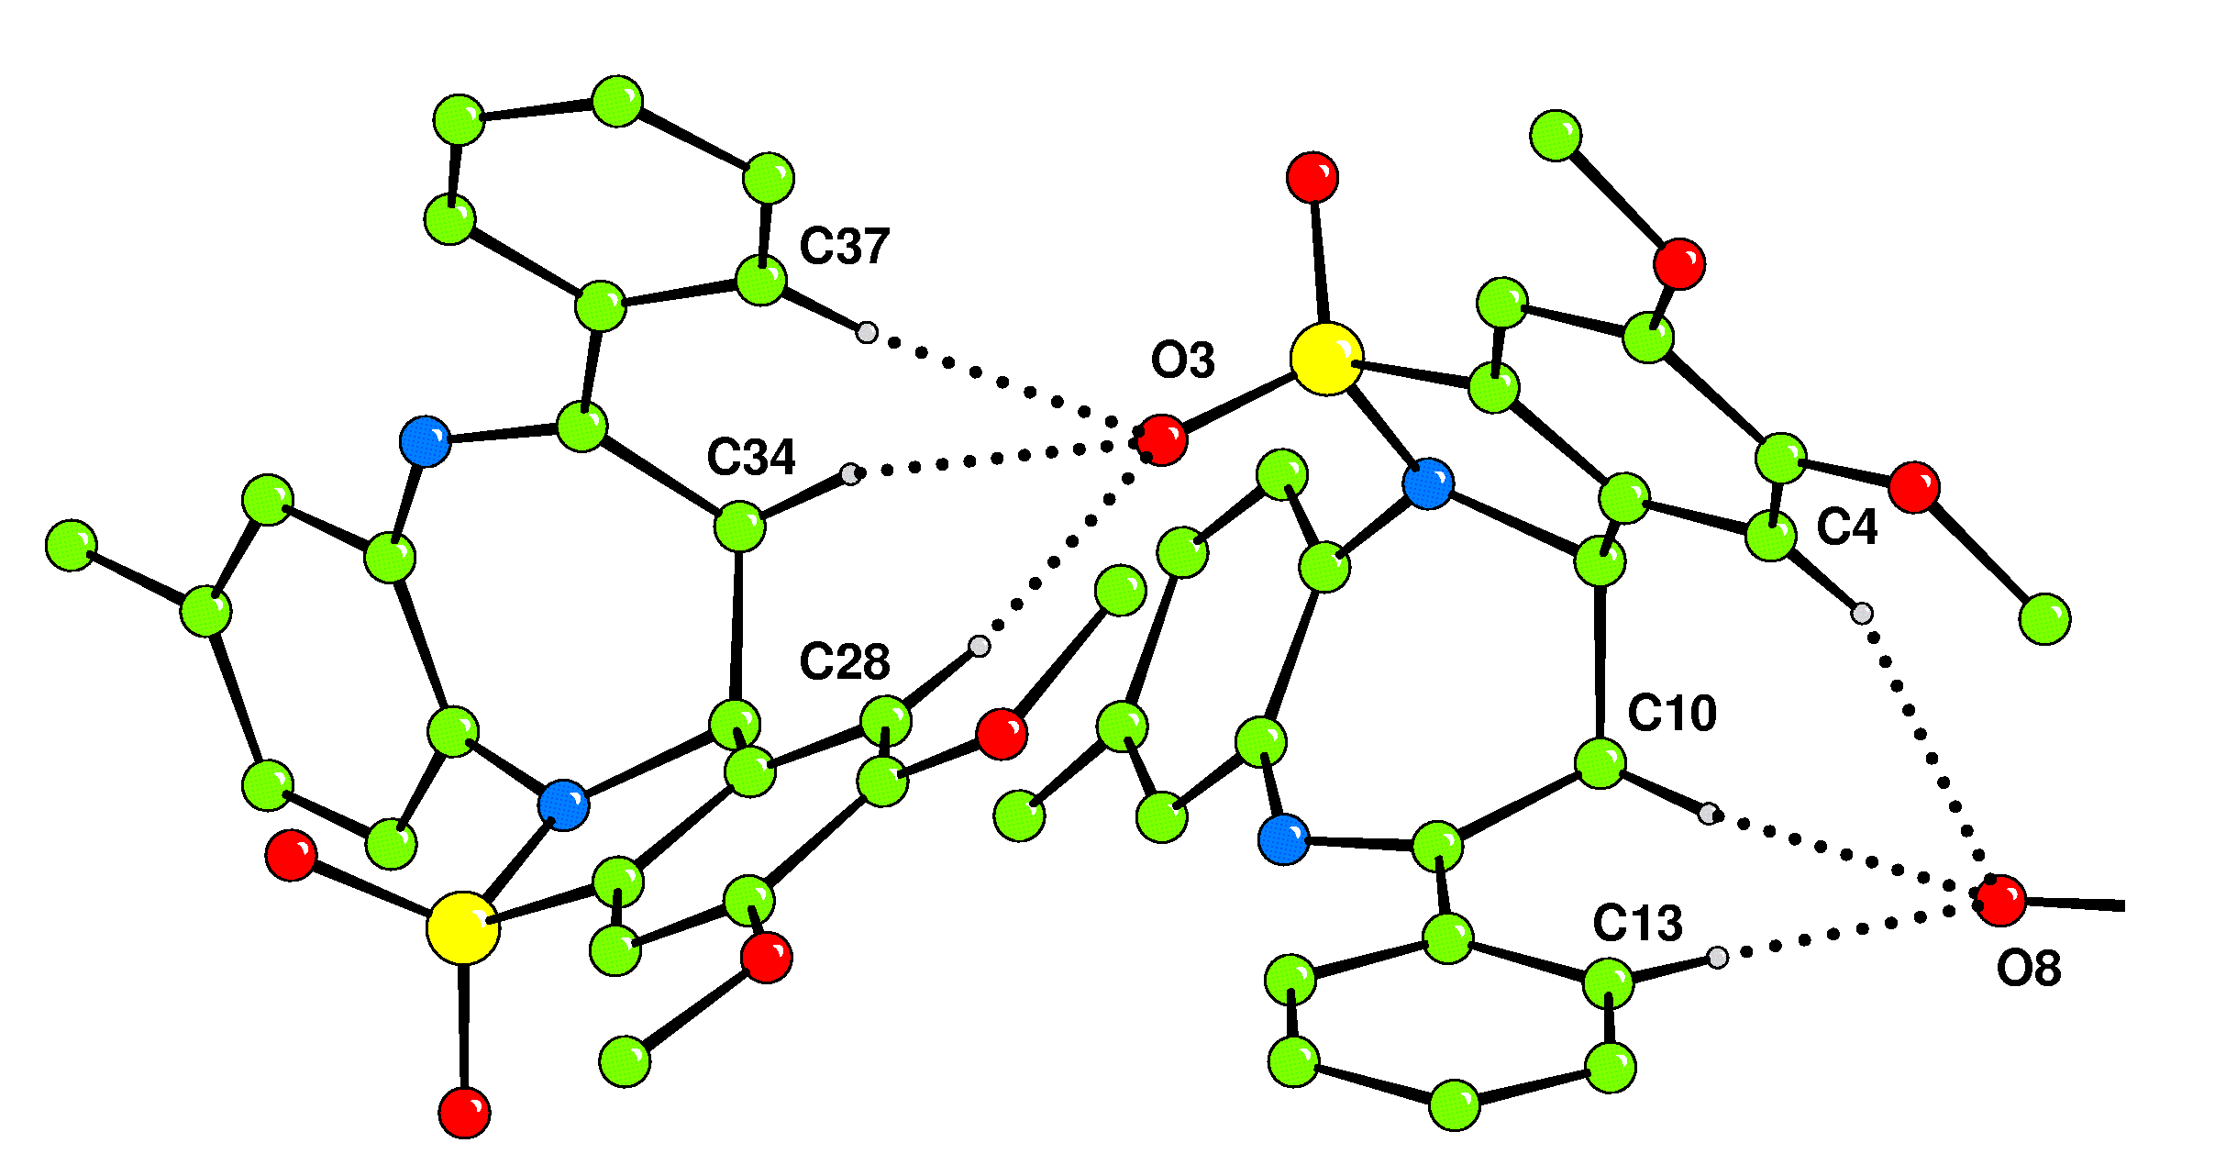

Detail of hydrogen bonded chains

Fit of the two independent molecules (1 has been reflected in a mirror plane)

