 | University of Southampton · Department of Chemistry  EPSRC National Crystallography Service | 

Table 1. Crystal data and structure refinement.

Identification code 01MEL003
Empirical formula C₁₆H₃₆N . SO₄H
Formula weight 339.53
Temperature 120(2) K
Wavelength 0.71073 Å
Crystal system Monoclinic
Space group P2₁/c
Unit cell dimensions a = 21.7299(4) Å
b = 21.3998(4) Å β = 91.318(3)°
c = 17.0880(4) Å
Volume 7944.1(3) Å³
Z 16
Density (calculated) 1.136 Mg / m³
Absorption coefficient 0.179 mm⁻¹
F(000) 3008
Crystal Colourless block
Crystal size 0.10 × 0.10 × 0.10 mm³
θ range for data collection 2.94 − 25.03°
Index ranges −25 ≤ h ≤ 25, −25 ≤ k ≤ 24, −20 ≤ l ≤ 20
Reflections collected 38718
Independent reflections 13981 [R_{int} = 0.0680]
Completeness to θ = 25.03° 99.6 %
Max. and min. transmission 0.9823 and 0.9823
Refinement method Full-matrix least-squares on F²
Data / restraints / parameters 13981 / 19 / 810
Goodness-of-fit on F² 1.021
Final R indices [F² > 2σ(F²)] R1 = 0.0735, wR2 = 0.2027
R indices (all data) R1 = 0.1357, wR2 = 0.2369
Extinction coefficient 0.0000(3)
Largest diff. peak and hole 1.259 and −0.691 e Å⁻³

Diffractometer: Nonius KappaCCD area detector (φ scans and ω scans to fill Ewald sphere). Cell determination: DirAx (Duisenberg, A.J.M.(1992). J. Appl. Cryst. 25, 92-96.) Data collection: Collect (Collect: Data collection software, R. Hooft, Nonius B.V., 1998). Data reduction and cell refinement: Denzo (Z. Otwinowski & W. Minor, Methods in Enzymology (1997) Vol. 276: Macromolecular Crystallography, part A, pp. 307−326; C. W. Carter, Jr. & R. M. Sweet, Eds., Academic Press). Absorption correction: SORTAV (R. H. Blessing, Acta Cryst. A51 (1995) 33−37; R. H. Blessing, J. Appl. Cryst. 30 (1997) 421−426). Structure solution: SHELXS97 (G. M. Sheldrick, Acta Cryst. (1990) A46 467−473). Structure refinement: SHELXL97 (G. M. Sheldrick (1997), University of Göttingen, Germany). Graphics: Cameron - A Molecular Graphics Package. (D. M. Watkin, L. Pearce and C. K. Prout, Chemical Crystallography Laboratory, University of Oxford, 1993).

Special details: All hydrogen atoms were placed in idealised positions and refined using a riding model.
Table 2. Atomic coordinates [× 10⁴], equivalent isotropic displacement parameters [Å² × 10³] and site occupancy factors. U_{eq} is defined as one third of the trace of the orthogonalized U^{ij} tensor.

Atom x y z U_{eq} S.o.f.

C1 3686(2) −427(2) 6738(2) 33(1) 1
C2 3981(2) −400(2) 5934(2) 40(1) 1
C3 3544(2) −97(2) 5337(2) 55(1) 1
C4 3831(3) −95(2) 4525(3) 66(2) 1
C5 4194(2) −1430(2) 7129(2) 33(1) 1
C6 3630(2) −1818(2) 6912(3) 52(1) 1
C7 3797(2) −2510(2) 6839(3) 51(1) 1
C8 3927(3) −2819(2) 7599(3) 69(2) 1
C9 4691(2) −460(2) 7482(2) 31(1) 1
C10 4680(2) 228(2) 7712(3) 40(1) 1
C11 5864(2) 311(3) 7668(4) 84(2) 1
C12 5283(3) 506(3) 7778(5) 124(3) 1
C13 3703(2) −738(2) 8110(2) 36(1) 1
C14 4004(2) −1078(3) 8804(3) 57(1) 1
C15 3650(3) −1065(3) 9521(3) 66(2) 1
C16 3950(3) −1406(3) 10196(3) 73(2) 1
C17 3098(2) 3036(2) 8920(2) 33(1) 1
C18 2772(2) 3642(2) 9095(2) 43(1) 1
C19 2705(3) 4035(2) 8341(3) 54(1) 1
C20 2316(3) 3733(2) 7705(3) 67(2) 1
C21 2815(2) 2548(2) 10204(2) 29(1) 1
C22 2264(2) 2194(2) 9880(2) 37(1) 1
C23 1817(2) 2048(3) 10525(3) 66(2) 1
C24 1563(3) 2620(4) 10915(3) 101(3) 1
C25 3580(2) 2065(2) 9309(2) 38(1) 1
C26 3812(2) 1601(2) 9918(2) 45(1) 1
C27 4087(2) 1033(2) 9527(3) 58(1) 1
C28 4295(3) 557(2) 10126(3) 71(2) 1
C29 3815(2) 3018(2) 10100(2) 44(1) 1
C30 4339(3) 3278(3) 9628(3) 83(2) 1
C31 4795(3) 3670(3) 10248(5) 103(2) 1
C32 5190(3) 3184(3) 10443(5) 120(3) 1
C33 8174(2) 1950(2) 8964(2) 37(1) 1
C34 7750(2) 1425(2) 9165(3) 53(1) 1
C35 7501(3) 1100(2) 8423(3) 59(1) 1
C36 7974(3) 744(3) 8002(3) 85(2) 1
C37 8846(2) 1874(2) 10175(2) 38(1) 1
C38 9355(2) 1526(2) 9783(3) 48(1) 1
C39 9715(3) 1168(3) 10415(3) 74(2) 1
C40 10220(4) 825(4) 10159(5) 135(3) 1
C41 7977(2) 2578(2) 10187(2) 33(1) 1
C42 7520(2) 3021(2) 9806(2) 49(1) 1
C43 7039(2) 3215(2) 10394(3) 50(1) 1
C44 7299(2) 3599(2) 11076(3) 54(1) 1
C45 8847(2) 2820(2) 9297(2) 30(1) 1
C46 9237(2) 3202(2) 9862(2) 37(1) 1
C47 9527(2) 3746(2) 9443(2) 35(1) 1
C48 9997(2) 4083(2) 9957(3) 53(1) 1
C49 9551(2) 5494(2) 7532(3) 43(1) 1
C50 9787(2) 4832(2) 7574(3) 55(1) 1
C51 10510(4) 4912(4) 7762(5) 132(3) 1
C52 10822(6) 4273(4) 7694(8) 261(7) 1
C53 8712(2) 6267(2) 7364(2) 35(1) 1
C54 8987(2) 6660(2) 6720(2) 38(1) 1
C55 8870(2) 7348(2) 6859(2) 38(1) 1
C56 9178(2) 7749(2) 6248(3) 51(1) 1
C57 8472(2) 5239(2) 7934(2) 39(1) 1
C58 8625(2) 5378(2) 8791(2) 38(1) 1
C59 8165(2) 5066(2) 9316(3) 49(1) 1
C60 8339(2) 5105(2) 10166(3) 59(1) 1
C61 8732(2) 5292(2) 6546(2) 38(1) 1
C62 8096(2) 5389(2) 6201(3) 45(1) 1
C63 8053(3) 5132(3) 5381(3) 74(2) 1
C64 7474(3) 5266(3) 4961(4) 99(2) 1
N1 4068(1) −761(1) 7361(2) 27(1) 1
N2 3325(2) 2667(2) 9632(2) 31(1) 1
N3 8460(2) 2309(2) 9653(2) 32(1) 1
N4 8868(2) 5569(2) 7342(2) 34(1) 1
O1 4656(1) 3100(1) 6555(2) 42(1) 1
O2 4232(1) 3519(2) 7740(2) 50(1) 1
O3 3591(1) 2909(1) 6849(2) 37(1) 1
O4 4396(1) 2424(2) 7636(2) 48(1) 1
O5 7775(2) 3701(2) 6512(2) 60(1) 1
O6 8733(1) 3611(1) 7231(2) 55(1) 1
O7 7784(1) 3791(1) 7904(2) 50(1) 1
O8 7970(1) 2798(1) 7320(2) 42(1) 1
O9 3822(1) 1435(1) 7038(2) 50(1) 1
O10 2907(1) 1998(1) 7382(2) 35(1) 1
O11 2860(2) 1182(1) 6402(2) 51(1) 1
O12 3018(2) 938(1) 7759(2) 49(1) 1
O13 8856(1) 2112(1) 6789(2) 44(1) 1
O14 9949(2) 1889(2) 6670(2) 60(1) 1
O15 9621(2) 2807(2) 7346(3) 74(1) 1
O16 9467(1) 1800(2) 7916(2) 54(1) 1
S1 4215(1) 3031(1) 7160(1) 33(1) 1
S2 8065(1) 3514(1) 7237(1) 32(1) 1
S3 3167(1) 1346(1) 7132(1) 30(1) 1
S4 9475(1) 2110(1) 7176(1) 38(1) 1
Table 3. Bond lengths [Å] and angles [°].

C1−N1 1.515(5)
C1−C2 1.531(5)
C2−C3 1.522(6)
C3−C4 1.533(6)
C5−N1 1.513(5)
C5−C6 1.519(6)
C6−C7 1.531(6)
C7−C8 1.478(6)
C9−N1 1.509(5)
C9−C10 1.524(5)
C10−C12 1.441(8)
C11−C12 1.347(8)
C13−N1 1.521(5)
C13−C14 1.526(6)
C14−C15 1.463(6)
C15−C16 1.501(7)
C17−C18 1.510(6)
C17−N2 1.523(5)
C18−C19 1.542(6)
C19−C20 1.508(6)
C21−C22 1.511(5)
C21−N2 1.515(5)
C22−C23 1.519(6)
C23−C24 1.504(8)
C25−N2 1.512(5)
C25−C26 1.517(6)
C26−C27 1.516(6)
C27−C28 1.506(6)
C29−C30 1.516(6)
C29−N2 1.517(5)
C30−C31 1.660(9)
C31−C32 1.385(8)
C33−C34 1.498(6)
C33−N3 1.526(5)
C34−C35 1.533(6)
C35−C36 1.479(7)
C37−C38 1.503(6)
C37−N3 1.526(5)
C38−C39 1.526(6)
C39−C40 1.398(9)
C41−C42 1.508(6)
C41−N3 1.521(5)
C42−C43 1.525(6)
C43−C44 1.524(6)
C45−C46 1.510(5)
C45−N3 1.515(5)
C46−C47 1.512(5)
C47−C48 1.515(6)
C49−C50 1.508(6)
C49−N4 1.521(5)
C50−C51 1.605(9)
C51−C52 1.532(2)
C53−C54 1.518(5)
C53−N4 1.532(5)
C54−C55 1.515(6)
C55−C56 1.519(6)
C57−N4 1.517(5)
C57−C58 1.524(6)
C58−C59 1.513(6)
C59−C60 1.495(6)
C61−C62 1.504(6)
C61−N4 1.506(5)
C62−C63 1.507(6)
C63−C64 1.461(7)
O1−S1 1.433(3)
O2−S1 1.439(3)
O3−S1 1.469(3)
O4−S1 1.577(3)
O5−S2 1.433(3)
O6−S2 1.466(3)
O7−S2 1.434(3)
O8−S2 1.553(3)
O9−S3 1.450(3)
O10−S3 1.568(3)
O11−S3 1.444(3)
O12−S3 1.426(3)
O13−S4 1.484(3)
O14−S4 1.440(3)
O15−S4 1.550(4)
O16−S4 1.428(3)

N1−C1−C2 114.5(3)
C3−C2−C1 110.5(4)
C2−C3−C4 110.3(4)
N1−C5−C6 115.5(3)
C5−C6−C7 110.8(4)
C8−C7−C6 113.7(4)
N1−C9−C10 115.4(3)
C12−C10−C9 113.5(4)
C11−C12−C10 135.5(6)
N1−C13−C14 114.6(3)
C15−C14−C13 114.8(4)
C14−C15−C16 114.0(5)
C18−C17−N2 115.6(3)
C17−C18−C19 109.8(3)
C20−C19−C18 114.1(4)
C22−C21−N2 115.6(3)
C21−C22−C23 110.6(3)
C24−C23−C22 113.7(5)
N2−C25−C26 115.2(3)
C27−C26−C25 110.5(3)
C28−C27−C26 111.0(4)
C30−C29−N2 115.4(3)
C29−C30−C31 106.9(4)
C32−C31−C30 97.6(6)
C34−C33−N3 116.2(3)
C33−C34−C35 111.0(4)
C36−C35−C34 113.7(5)
C38−C37−N3 116.1(3)
C37−C38−C39 107.7(4)
C40−C39−C38 115.9(5)
C42−C41−N3 115.9(3)
C41−C42−C43 110.0(3)
C44−C43−C42 113.8(4)
C46−C45−N3 116.3(3)
C45−C46−C47 110.4(3)
C46−C47−C48 112.0(3)
C50−C49−N4 116.0(4)
C49−C50−C51 103.9(4)
C52−C51−C50 108.9(8)
C54−C53−N4 115.5(3)
C55−C54−C53 110.8(3)
C54−C55−C56 111.3(4)
N4−C57−C58 115.8(3)
C59−C58−C57 110.6(4)
C60−C59−C58 113.3(4)
C62−C61−N4 117.2(3)
C61−C62−C63 110.5(4)
C64−C63−C62 114.8(5)
C9−N1−C5 105.9(3)
C9−N1−C1 111.7(3)
C5−N1−C1 111.3(3)
C9−N1−C13 110.8(3)
C5−N1−C13 110.6(3)
C1−N1−C13 106.7(3)
C25−N2−C21 111.9(3)
C25−N2−C29 110.8(3)
C21−N2−C29 105.0(3)
C25−N2−C17 105.4(3)
C21−N2−C17 112.0(3)
C29−N2−C17 112.0(3)
C45−N3−C41 111.4(3)
C45−N3−C37 111.9(3)
C41−N3−C37 105.0(3)
C45−N3−C33 105.8(3)
C41−N3−C33 112.2(3)
C37−N3−C33 110.6(3)
C61−N4−C57 108.5(3)
C61−N4−C49 108.7(3)
C57−N4−C49 112.0(3)
C61−N4−C53 111.6(3)
C57−N4−C53 108.0(3)
C49−N4−C53 108.2(3)
O1−S1−O2 114.51(17)
O1−S1−O3 112.60(16)
O2−S1−O3 112.75(18)
O1−S1−O4 107.13(18)
O2−S1−O4 103.88(19)
O3−S1−O4 104.91(17)
O5−S2−O7 112.70(19)
O5−S2−O6 111.7(2)
O7−S2−O6 112.7(2)
O5−S2−O8 107.31(19)
O7−S2−O8 105.93(18)
O6−S2−O8 105.90(17)
O12−S3−O11 113.10(18)
O12−S3−O9 113.84(19)
O11−S3−O9 111.8(2)
O12−S3−O10 104.51(18)
O11−S3−O10 106.86(17)
O9−S3−O10 105.95(17)
O16−S4−O14 113.72(19)
O16−S4−O13 111.51(19)
O14−S4−O13 112.69(18)
O16−S4−O15 106.7(2)
O14−S4−O15 106.4(2)
O13−S4−O15 105.15(18)

Table 4. Anisotropic displacement parameters [Å²× 10³]. The anisotropic displacement
factor exponent takes the form: −2π ²[h²a*²U¹¹ + ... + 2 h k a* b* U¹² ].

Atom U¹¹ U²² U³³ U²³ U¹³ U¹²

C1 28(2) 30(2) 42(2) 0(2) −7(2) 8(2)
C2 42(3) 39(3) 38(2) 4(2) −5(2) 8(2)
C3 77(4) 52(3) 37(3) −3(2) −8(3) 25(3)
C4 102(5) 55(3) 42(3) 5(2) −8(3) 26(3)
C5 35(2) 25(2) 38(2) −2(2) −6(2) 2(2)
C6 45(3) 32(3) 77(3) −14(2) −24(3) 1(2)
C7 62(3) 33(3) 57(3) −13(2) −8(3) −4(2)
C8 86(4) 37(3) 84(4) 9(3) −2(3) −11(3)
C9 27(2) 34(2) 32(2) −1(2) 0(2) −1(2)
C10 39(3) 29(2) 53(3) −4(2) 1(2) −8(2)
C11 38(3) 75(4) 139(6) −25(4) 7(4) −4(3)
C12 90(4) 89(4) 194(5) −29(4) 9(4) −17(3)
C13 31(2) 32(2) 44(3) −3(2) 10(2) −2(2)
C14 56(3) 80(4) 36(3) 4(3) 6(2) 13(3)
C15 77(4) 68(4) 54(3) 6(3) 13(3) −6(3)
C16 87(4) 84(4) 48(3) 22(3) 1(3) −2(3)
C17 42(3) 36(2) 21(2) 3(2) 0(2) −4(2)
C18 65(3) 36(3) 28(2) −1(2) 3(2) −2(2)
C19 72(4) 44(3) 46(3) 4(2) 3(3) 4(3)
C20 79(4) 66(4) 55(3) 7(3) −24(3) 9(3)
C21 35(2) 35(2) 18(2) 1(2) 2(2) −1(2)
C22 32(2) 41(3) 37(2) 3(2) −4(2) −5(2)
C23 50(3) 105(5) 42(3) 12(3) −5(3) −28(3)
C24 57(4) 192(8) 54(4) −49(4) 23(3) −31(4)
C25 41(3) 49(3) 24(2) −8(2) −1(2) 11(2)
C26 53(3) 49(3) 32(2) −11(2) −9(2) 16(2)
C27 52(3) 73(4) 47(3) −18(3) −13(2) 30(3)
C28 81(4) 58(3) 73(4) −22(3) −36(3) 30(3)
C29 44(3) 65(3) 22(2) −7(2) −3(2) −30(2)
C30 71(3) 125(4) 52(3) −4(3) −2(3) −46(3)
C31 64(4) 74(5) 171(7) 20(5) 41(5) −15(4)
C32 89(5) 74(5) 197(8) 58(5) 33(5) 13(4)
C33 40(3) 42(3) 29(2) 3(2) −9(2) −6(2)
C34 60(3) 54(3) 44(3) 10(2) −17(2) −23(3)
C35 66(4) 48(3) 60(3) 0(3) −20(3) −16(3)
C36 106(5) 67(4) 80(4) −11(3) −18(4) −13(4)
C37 43(3) 39(3) 30(2) 12(2) −13(2) −2(2)
C38 51(3) 41(3) 52(3) 13(2) −5(2) 7(2)
C39 66(4) 73(4) 82(4) 22(3) 8(3) 36(3)
C40 154(8) 128(7) 124(6) 41(6) 22(6) 10(6)
C41 28(2) 47(3) 25(2) 2(2) −2(2) −8(2)
C42 35(3) 71(3) 39(3) 7(2) −5(2) 6(2)
C43 46(3) 60(3) 43(3) 1(2) −1(2) 5(2)
C44 53(3) 51(3) 57(3) 2(3) −4(3) 6(2)
C45 31(2) 32(2) 26(2) 6(2) −2(2) −1(2)
C46 37(3) 39(2) 33(2) 1(2) −4(2) −3(2)
C47 32(2) 27(2) 46(3) 2(2) 7(2) 1(2)
C48 55(3) 38(3) 65(3) −5(2) 4(3) −10(2)
C49 27(2) 59(3) 43(3) 3(2) 0(2) −8(2)
C50 35(3) 71(4) 59(3) 11(3) −2(2) 11(3)
C51 118(7) 119(6) 158(7) −5(6) −20(6) 75(5)
C52 256(8) 266(8) 260(8) 12(5) 4(5) −4(5)
C53 36(3) 30(2) 37(2) −3(2) 3(2) −6(2)
C54 44(3) 39(3) 31(2) −1(2) −1(2) −14(2)
C55 49(3) 31(2) 34(2) 5(2) −6(2) −8(2)
C56 49(3) 56(3) 46(3) 11(2) −6(2) −17(2)
C57 30(2) 32(2) 57(3) 1(2) 5(2) −7(2)
C58 36(3) 35(2) 45(3) 0(2) 8(2) −5(2)
C59 42(3) 44(3) 62(3) 16(2) 14(2) 5(2)
C60 69(4) 53(3) 55(3) 6(3) 24(3) 3(3)
C61 39(3) 36(2) 39(2) −8(2) 4(2) −3(2)
C62 38(3) 38(3) 57(3) −7(2) −11(2) −2(2)
C63 68(4) 66(4) 85(4) −36(3) −36(3) 23(3)
C64 94(5) 78(4) 122(6) −34(4) −44(4) 12(4)
N1 24(2) 27(2) 31(2) −3(2) −2(2) 1(1)
N2 32(2) 39(2) 21(2) −6(2) 0(2) −6(2)
N3 35(2) 34(2) 25(2) 6(2) −9(2) −2(2)
N4 31(2) 35(2) 36(2) 0(2) 0(2) −7(2)
O1 39(2) 58(2) 27(2) 4(1) 1(1) −12(2)
O2 51(2) 64(2) 37(2) −14(2) 8(2) −24(2)
O3 34(2) 42(2) 34(2) 4(1) −9(1) −8(1)
O4 38(2) 61(2) 43(2) 16(2) −15(2) −10(2)
O5 79(3) 59(2) 41(2) 11(2) −10(2) 27(2)
O6 30(2) 38(2) 99(3) −8(2) 8(2) −1(1)
O7 55(2) 50(2) 47(2) −15(2) 14(2) −4(2)
O8 35(2) 33(2) 57(2) 7(2) 0(2) −2(1)
O9 31(2) 37(2) 82(2) 11(2) 13(2) 7(1)
O10 30(2) 35(2) 42(2) −6(2) 5(1) −5(1)
O11 82(3) 38(2) 34(2) −6(1) −12(2) −1(2)
O12 59(2) 46(2) 43(2) 16(2) 2(2) −8(2)
O13 41(2) 52(2) 38(2) −7(2) −16(1) 9(2)
O14 47(2) 95(3) 37(2) −4(2) 1(2) 26(2)
O15 50(2) 45(2) 124(3) −8(2) −39(2) 8(2)
O16 48(2) 78(2) 34(2) 9(2) −4(2) 19(2)
S1 33(1) 44(1) 21(1) 1(1) −3(1) −13(1)
S2 33(1) 29(1) 33(1) −1(1) 2(1) 3(1)
S3 36(1) 26(1) 29(1) 3(1) 2(1) −1(1)
S4 39(1) 42(1) 34(1) −3(1) −7(1) 14(1)

Table 5. Hydrogen coordinates [× 10⁴] and isotropic displacement parameters [Å² × 10³].

Atom x y z U_{eq} S.o.f.

H1A 3608 6 6916 40 1
H1B 3283 −640 6683 40 1
H2A 4368 −157 5971 48 1
H2B 4083 −828 5761 48 1
H3A 3456 338 5498 66 1
H3B 3151 −330 5314 66 1
H4A 3546 102 4147 100 1
H4B 3912 −526 4363 100 1
H4C 4218 140 4547 100 1
H5A 4416 −1639 7569 39 1
H5B 4472 −1428 6678 39 1
H6A 3451 −1667 6409 62 1
H6B 3316 −1766 7318 62 1
H7A 3454 −2731 6568 61 1
H7B 4164 −2548 6510 61 1
H8A 4035 −3257 7509 104 1
H8B 3560 −2797 7922 104 1
H8C 4270 −2607 7868 104 1
H9A 4922 −501 6992 37 1
H9B 4920 −694 7894 37 1
H10A 4433 462 7316 49 1
H10B 4473 270 8220 49 1
H11A 6153 607 7913 126 1
H11B 5939 286 7106 126 1
H11C 5921 −103 7906 126 1
H12A 5247 880 7439 149 1
H12B 5298 670 8320 149 1
H13A 3292 −924 8004 43 1
H13B 3641 −295 8255 43 1
H14A 4073 −1519 8655 69 1
H14B 4412 −887 8915 69 1
H15A 3241 −1253 9411 79 1
H15B 3585 −625 9675 79 1
H16A 3690 −1375 10655 109 1
H16B 4353 −1219 10317 109 1
H16C 4004 −1847 10057 109 1
H17A 3455 3130 8591 40 1
H17B 2813 2768 8609 40 1
H18A 3011 3879 9496 52 1
H18B 2360 3553 9304 52 1
H19A 2521 4444 8474 65 1
H19B 3120 4117 8137 65 1
H20A 2300 4005 7245 101 1
H20B 1899 3666 7894 101 1
H20C 2497 3330 7564 101 1
H21A 2989 2312 10655 35 1
H21B 2672 2956 10404 35 1
H22A 2403 1800 9638 44 1
H22B 2054 2447 9470 44 1
H23A 1470 1801 10301 79 1
H23B 2029 1786 10926 79 1
H24A 1279 2493 11323 151 1
H24B 1343 2877 10526 151 1
H24C 1902 2862 11152 151 1
H25A 3923 2169 8959 46 1
H25B 3254 1861 8985 46 1
H26A 4129 1803 10259 54 1
H26B 3468 1470 10250 54 1
H27A 3776 843 9168 69 1
H27B 4442 1163 9213 69 1
H28A 4479 199 9860 107 1
H28B 3940 416 10423 107 1
H28C 4600 746 10484 107 1
H29A 3616 3368 10376 53 1
H29B 3990 2733 10504 53 1
H30A 4177 3560 9212 99 1
H30B 4569 2935 9380 99 1
H31A 5010 4020 9990 123 1
H31B 4571 3828 10706 123 1
H32A 5512 3335 10807 179 1
H32B 5380 3024 9968 179 1
H32C 4959 2848 10691 179 1
H33A 7943 2250 8629 45 1
H33B 8511 1778 8649 45 1
H34A 7402 1590 9466 64 1
H34B 7974 1118 9498 64 1
H35A 7167 811 8568 70 1
H35B 7322 1419 8066 70 1
H36A 7788 559 7528 127 1
H36B 8138 411 8341 127 1
H36C 8308 1025 7857 127 1
H37A 9029 2124 10608 46 1
H37B 8567 1563 10410 46 1
H38A 9629 1824 9516 58 1
H38B 9181 1233 9388 58 1
H39A 9864 1470 10815 88 1
H39B 9430 878 10673 88 1
H40A 10412 605 10604 203 1
H40B 10520 1109 9928 203 1
H40C 10081 520 9765 203 1
H41A 7746 2227 10417 40 1
H41B 8190 2801 10622 40 1
H42A 7316 2814 9352 58 1
H42B 7738 3395 9615 58 1
H43A 6716 3463 10118 60 1
H43B 6841 2835 10603 60 1
H44A 6968 3700 11435 81 1
H44B 7478 3986 10877 81 1
H44C 7618 3357 11355 81 1
H45A 9123 2625 8913 36 1
H45B 8569 3107 9005 36 1
H46A 9563 2936 10099 44 1
H46B 8977 3360 10288 44 1
H47A 9201 4044 9276 42 1
H47B 9729 3591 8967 42 1
H48A 10175 4430 9664 79 1
H48B 10324 3791 10117 79 1
H48C 9797 4246 10423 79 1
H49A 9784 5721 7130 52 1
H49B 9641 5699 8041 52 1
H50A 9715 4612 7071 66 1
H50B 9585 4596 7995 66 1
H51A 10691 5209 7387 158 1
H51B 10574 5080 8297 158 1
H52A 11262 4315 7818 391 1
H52B 10766 4114 7159 391 1
H52C 10637 3980 8062 391 1
H53A 8259 6313 7334 42 1
H53B 8855 6437 7875 42 1
H54A 9436 6583 6703 45 1
H54B 8803 6535 6208 45 1
H55A 9030 7465 7386 46 1
H55B 8421 7428 6841 46 1
H56A 9091 8191 6349 76 1
H56B 9018 7636 5726 76 1
H56C 9624 7679 6274 76 1
H57A 8509 4782 7851 47 1
H57B 8037 5354 7827 47 1
H58A 9044 5224 8924 46 1
H58B 8618 5835 8878 46 1
H59A 7757 5266 9231 59 1
H59B 8125 4621 9165 59 1
H60A 8022 4901 10474 88 1
H60B 8375 5545 10321 88 1
H60C 8734 4895 10258 88 1
H61A 9032 5467 6177 45 1
H61B 8808 4836 6578 45 1
H62A 7999 5841 6193 54 1
H62B 7791 5178 6531 54 1
H63A 8395 5306 5077 88 1
H63B 8109 4673 5405 88 1
H64A 7480 5073 4441 148 1
H64B 7424 5719 4906 148 1
H64C 7130 5095 5255 148 1
H10 3125(18) 2247(18) 7190(20) 27(13) 1
H4 4240(30) 2100(30) 7410(30) 90(20) 1
H8 8290(30) 2600(30) 7090(40) 130(30) 1
H15 9320(40) 3020(40) 7330(50) 170(40) 1

Table 6. Hydrogen bonds [Å and °].

D−H···A d(D−H) d(H···A) d(D···A) ∠(DHA)

O10−H10...O3 0.79(4) 1.84(4) 2.628(4) 171(4)
O4−H4...O9 0.85(6) 1.81(6) 2.649(5) 171(6)
O8−H8...O13 0.92(7) 1.70(7) 2.603(4) 168(7)
O15−H15...O6 0.81(8) 1.79(8) 2.590(5) 170(9)

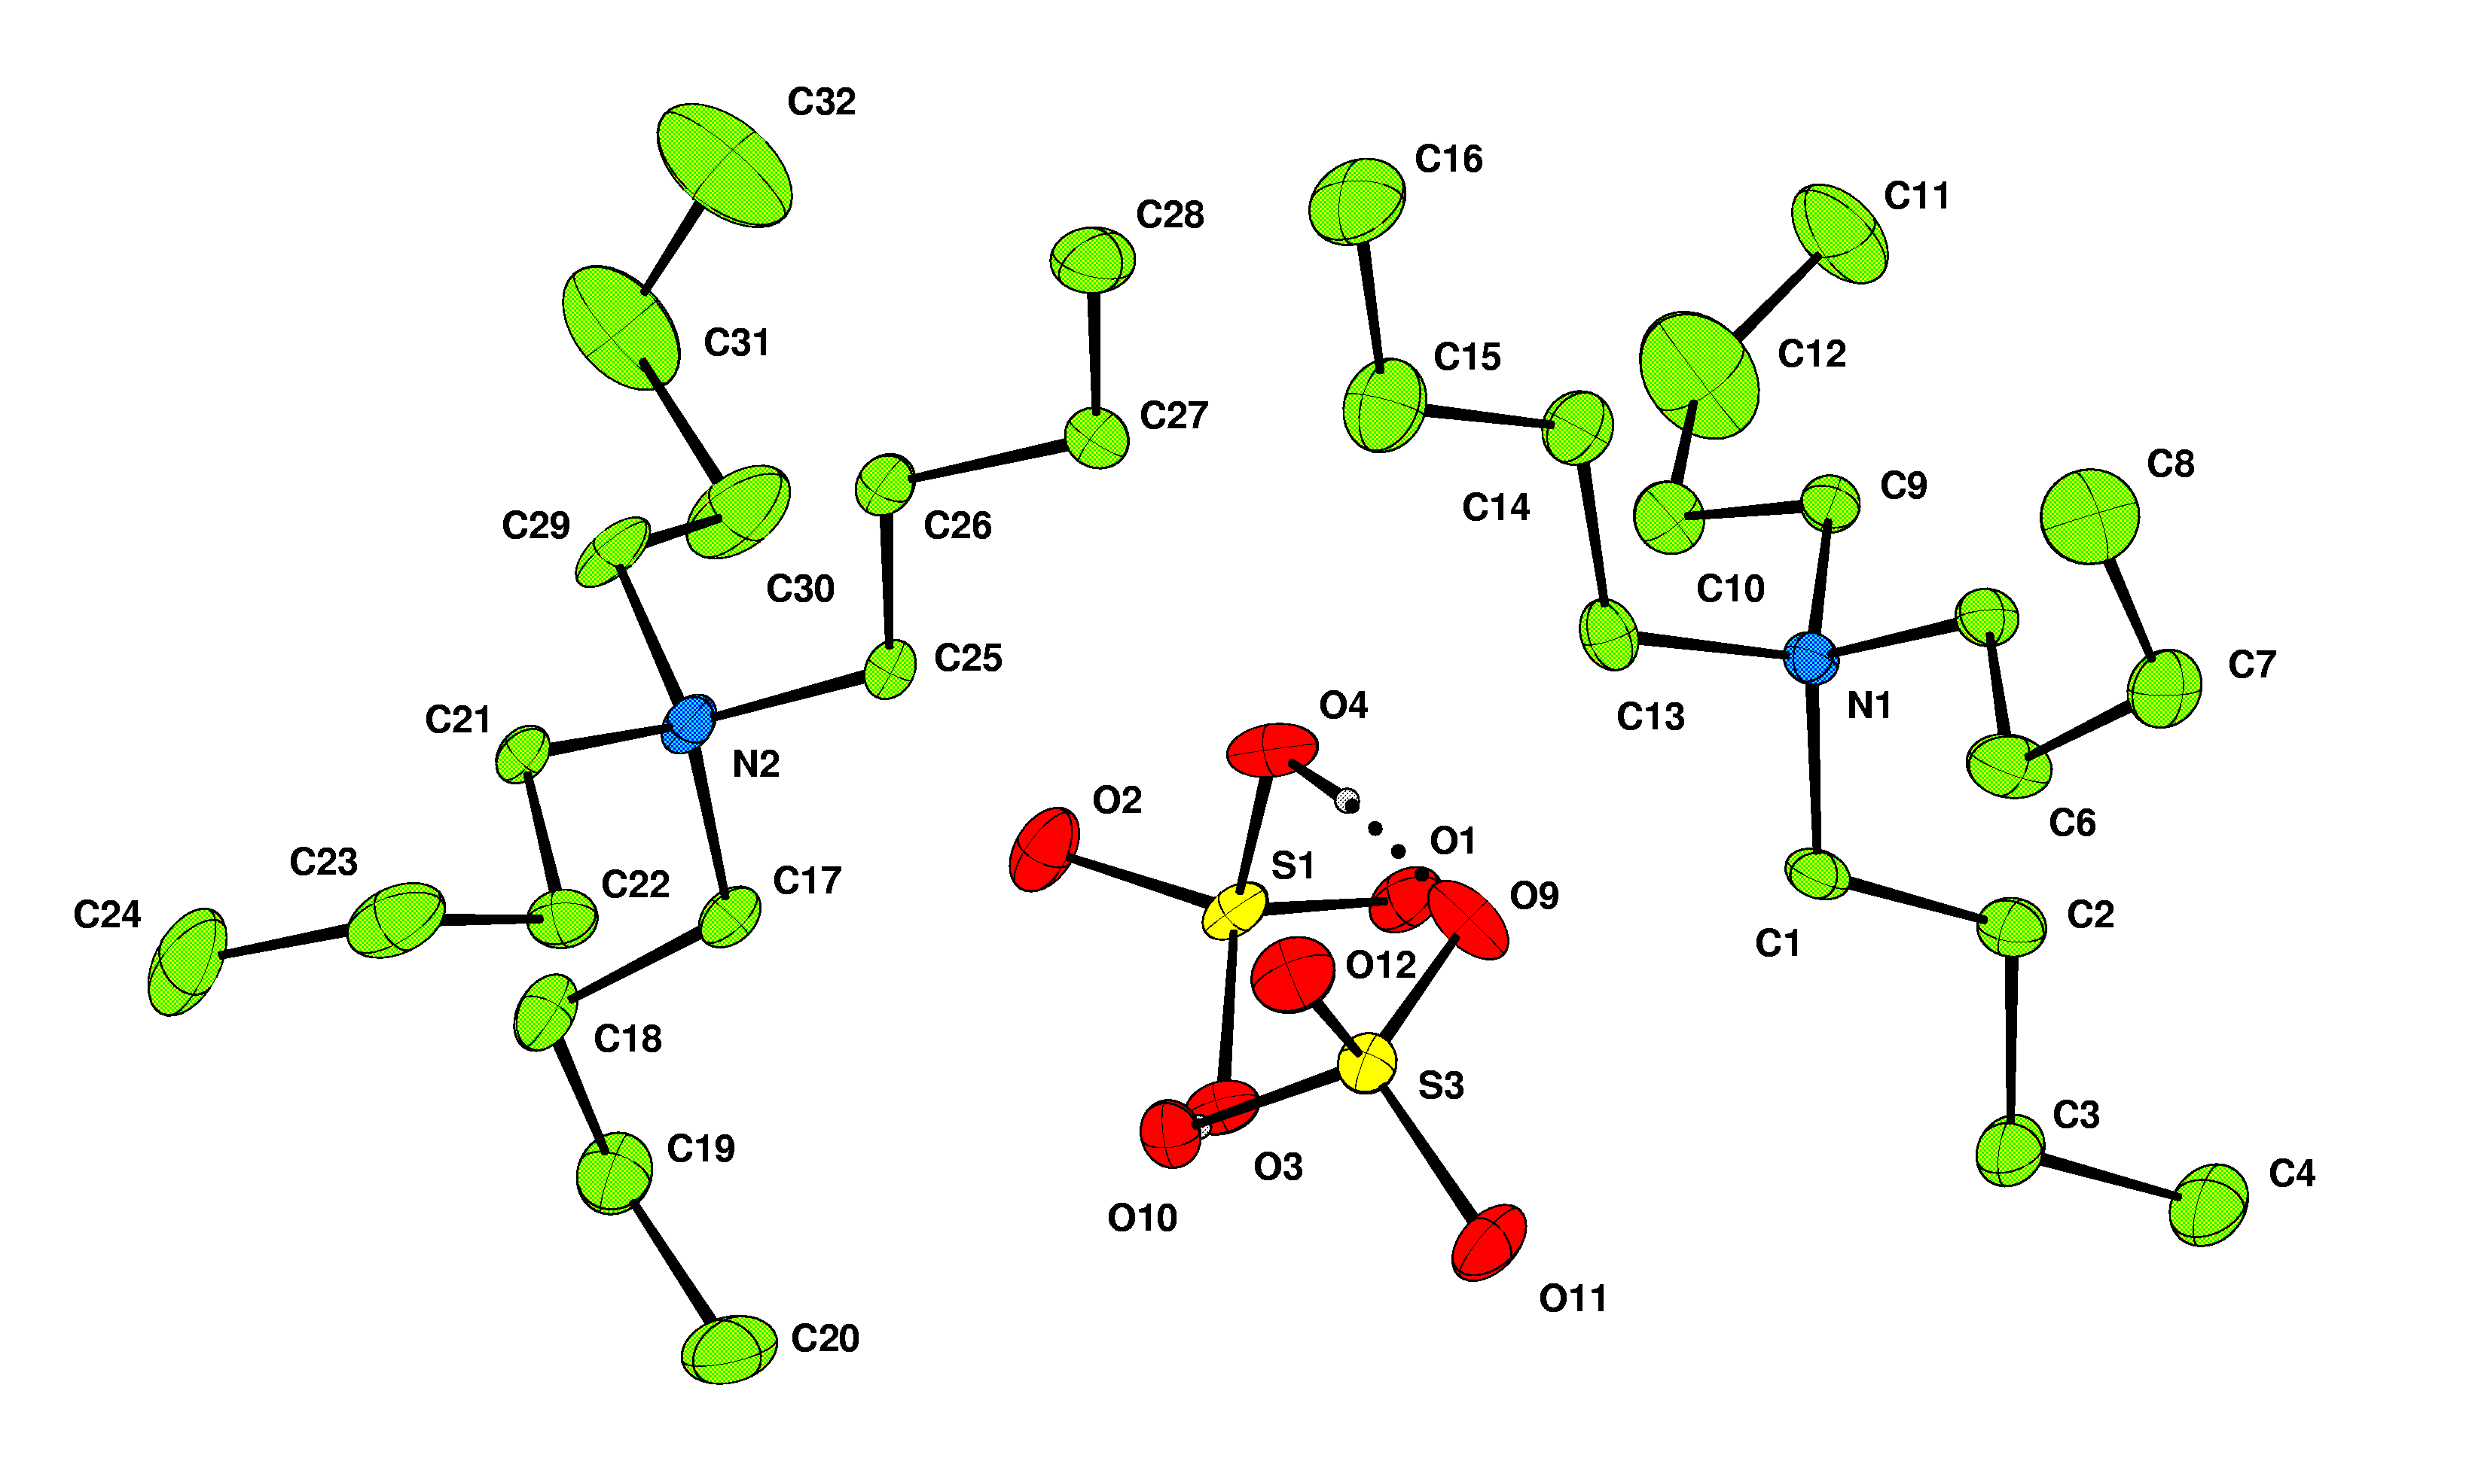

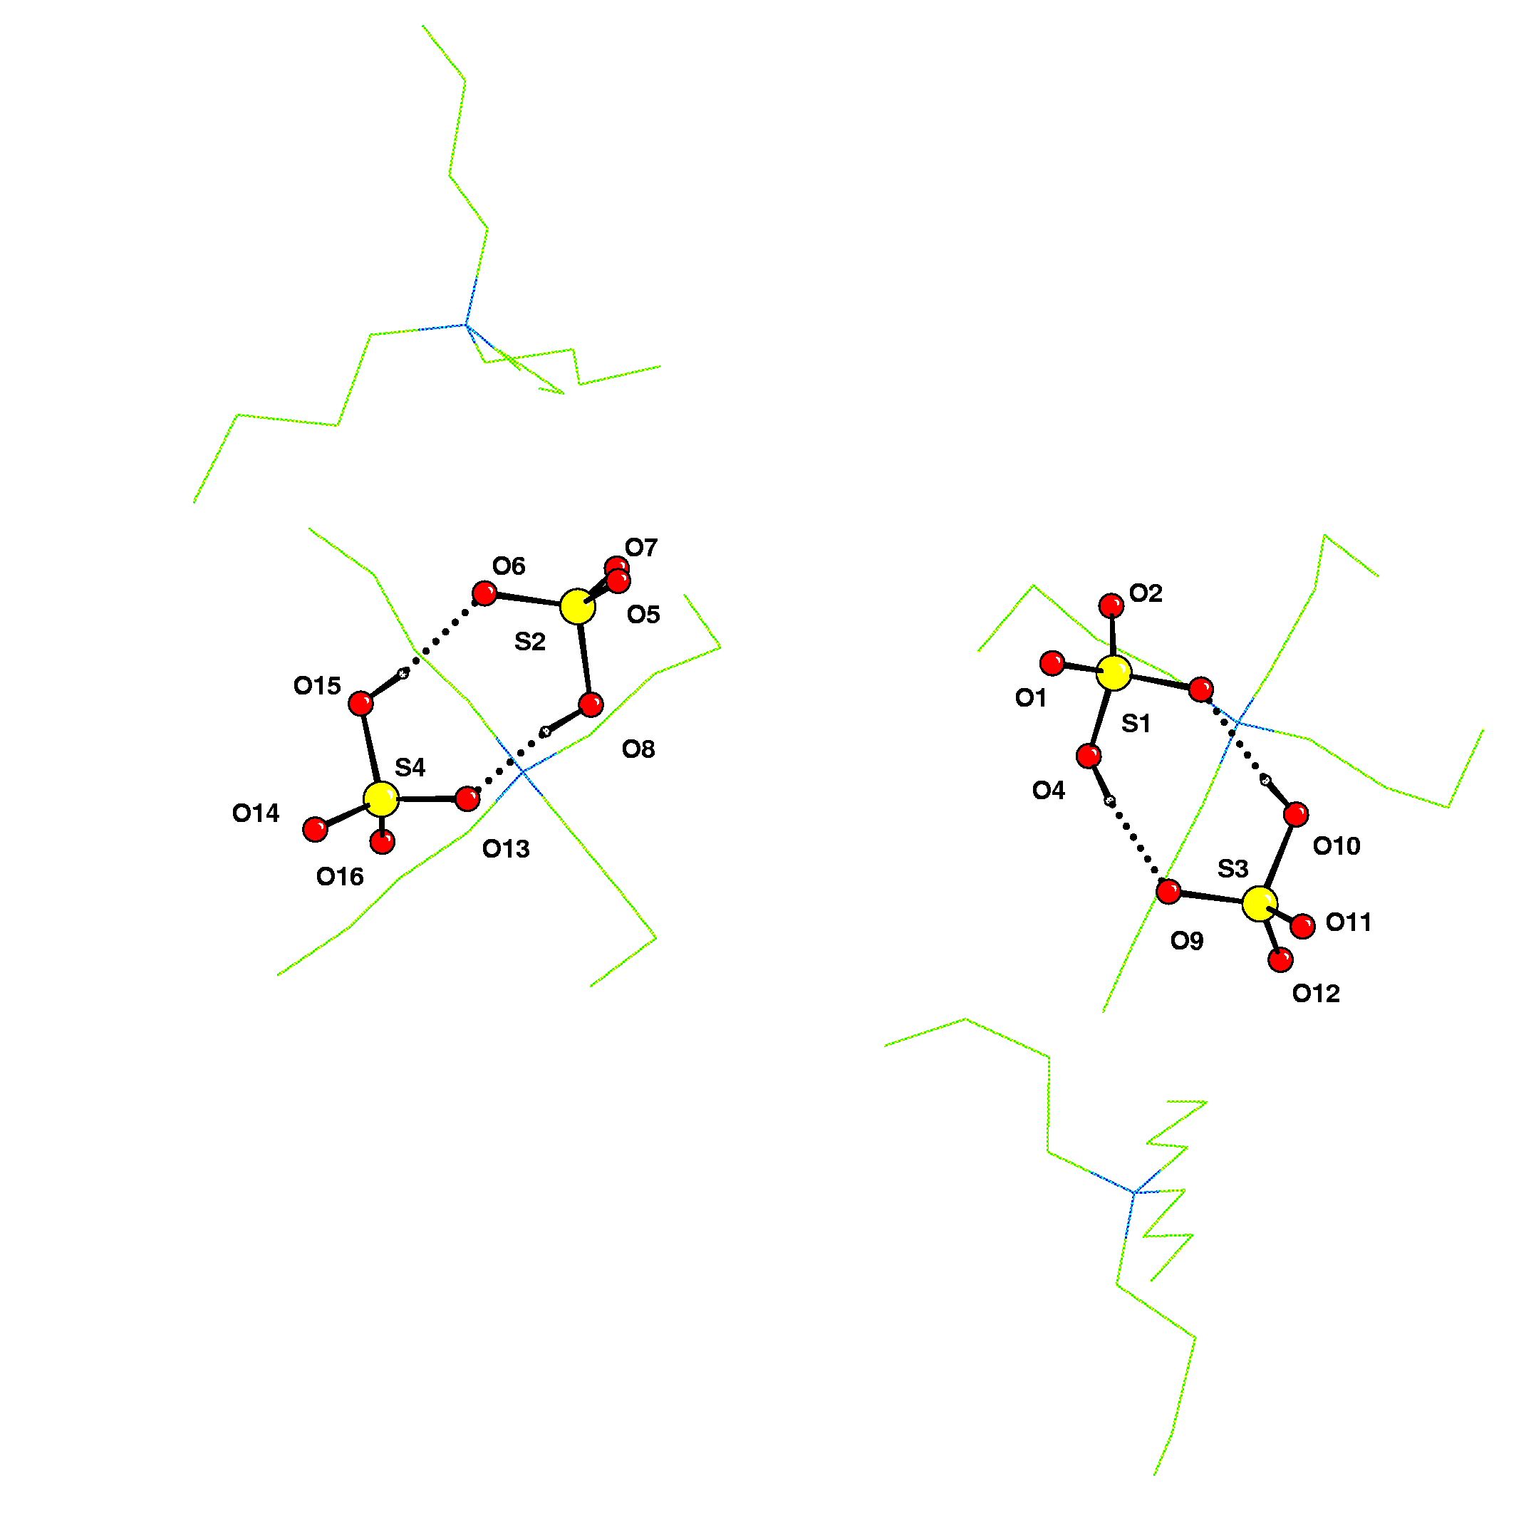

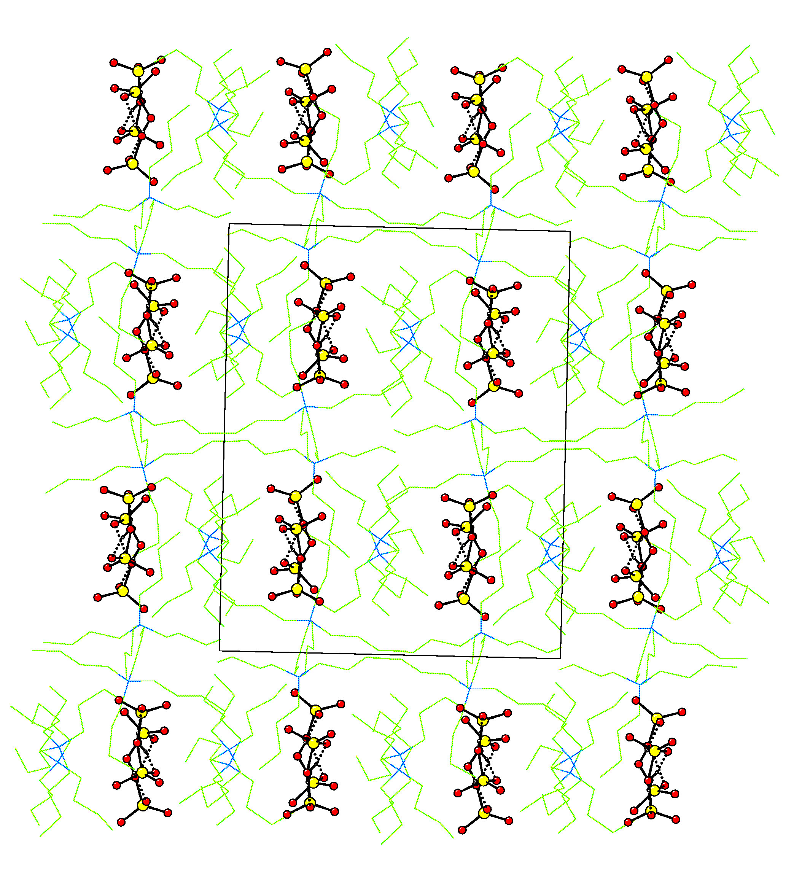 | 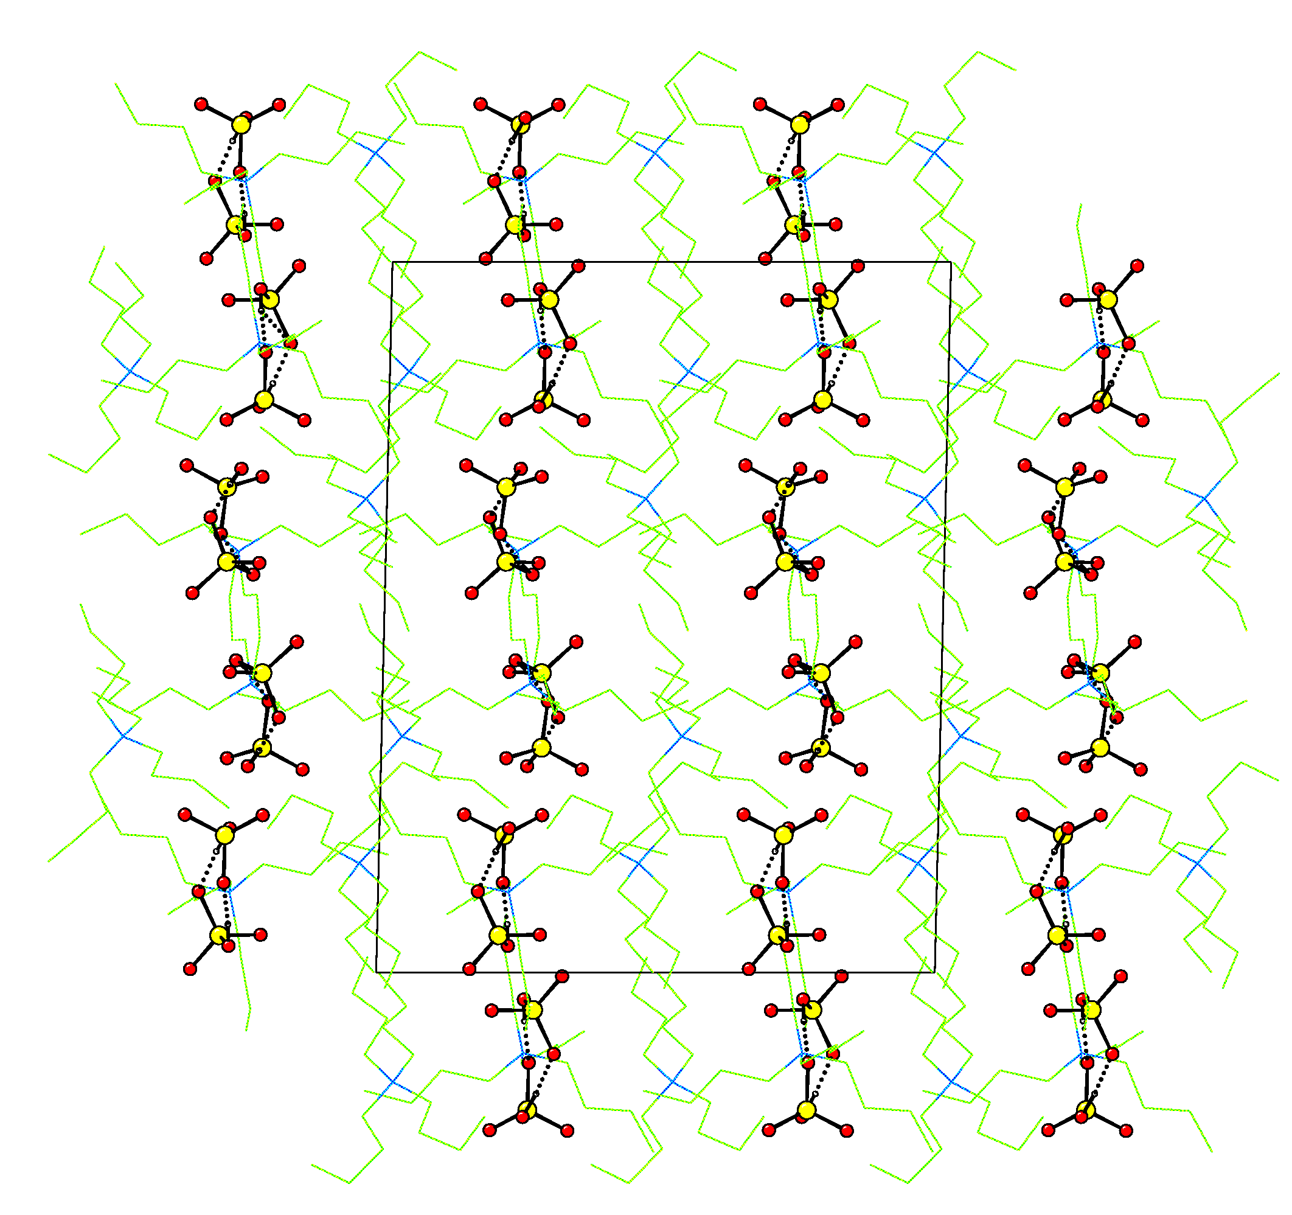 | 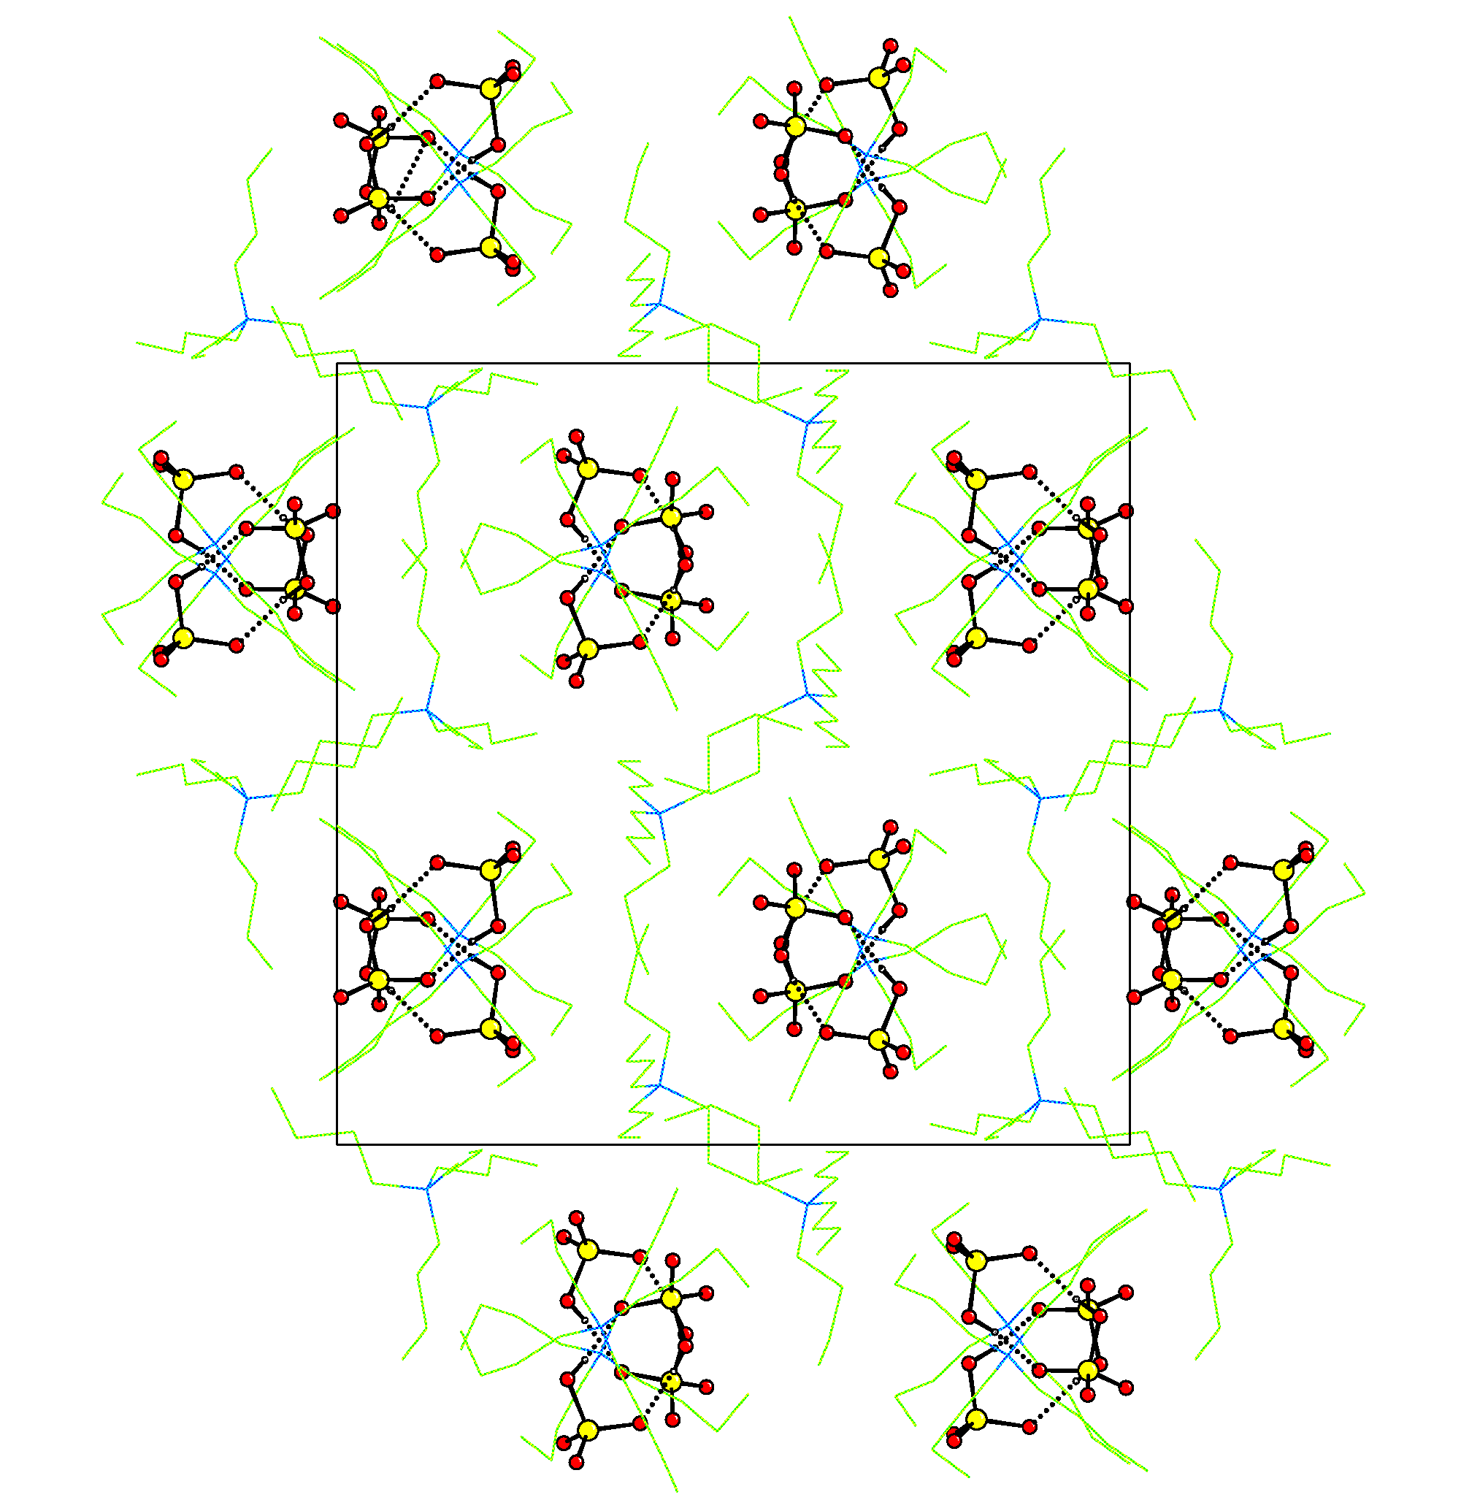
Looking down a | Looking down b | Looking down c

