 | University of Southampton · Department of Chemistry  EPSRC National Crystallography Service | 

Table 1. Crystal data and structure refinement.

Identification code 01SOT013
Empirical formula C₂₆H₃₁N₃O₂
Formula weight 417.54
Temperature 150(2) K
Wavelength 0.71073 Å
Crystal system Monoclinic
Space group Cc
Unit cell dimensions a = 25.5294(5) Å
b = 18.9718(5) Å β = 103.111(2)°
c = 9.7130(2) Å
Volume 4581.75(18) Å³
Z 8 (2 Molecules in asymmetric unit)
Density (calculated) 1.211 Mg / m³
Absorption coefficient 0.077 mm⁻¹
F(000) 1792
Crystal Colourless block
Crystal size 0.20 × 0.10 × 0.10 mm³
θ range for data collection 3.04 − 23.26°
Index ranges −28 ≤ h ≤ 28, −21 ≤ k ≤ 21, −10 ≤ l ≤ 10
Reflections collected 18454
Independent reflections 6361 [R_{int} = 0.0810]
Completeness to θ = 23.26° 99.7 %

Max. and min. transmission 0.9923 and 0.9847
Refinement method Full-matrix least-squares on F²
Data / restraints / parameters 6361 / 20 / 560
Goodness-of-fit on F² 1.082
Final R indices [F² > 2σ(F²)] R1 = 0.0567, wR2 = 0.1438
R indices (all data) R1 = 0.0709, wR2 = 0.1555
Absolute structure parameter Not reliably determined
Extinction coefficient 0.0024(6)
Largest diff. peak and hole 0.667 and −0.410 e Å⁻³

Diffractometer: Nonius KappaCCD area detector (φ scans and ω scans to fill Ewald sphere). Cell determination: DirAx (Duisenberg, A.J.M.(1992). J. Appl. Cryst. 25, 92-96.) Data collection: Collect (Collect: Data collection software, R. Hooft, Nonius B.V., 1998). Data reduction and cell refinement: Denzo (Z. Otwinowski & W. Minor, Methods in Enzymology (1997) Vol. 276: Macromolecular Crystallography, part A, pp. 307−326; C. W. Carter, Jr. & R. M. Sweet, Eds., Academic Press). Absorption correction: SORTAV (R. H. Blessing, Acta Cryst. A51 (1995) 33−37; R. H. Blessing, J. Appl. Cryst. 30 (1997) 421−426). Structure solution: SHELXS97 (G. M. Sheldrick, Acta Cryst. (1990) A46 467−473). Structure refinement: SHELXL97 (G. M. Sheldrick (1997), University of Göttingen, Germany). Graphics: Cameron - A Molecular Graphics Package. (D. M. Watkin, L. Pearce and C. K. Prout, Chemical Crystallography Laboratory, University of Oxford, 1993).

Special details: All hydrogen atoms were placed in idealised positions and refined using a riding model.
Table 2. Atomic coordinates [× 10⁴], equivalent isotropic displacement parameters [Å² × 10³] and site occupancy factors. U_{eq} is defined as one third of the trace of the orthogonalized U^{ij} tensor.

Atom x y z U_{eq} S.o.f.

Molecule 1
N1 2074(2) 13048(2) 1320(4) 36(1) 1
N2 2002(1) 11142(2) 1157(3) 24(1) 1
N3 1621(1) 9544(2) 2466(3) 26(1) 1
O1 2543(1) 12278(2) 299(3) 35(1) 1
O2 1780(1) 9661(1) 272(3) 26(1) 1
C1 1229(2) 15101(3) 1019(8) 73(2) 1
C2 1633(2) 14521(2) 1544(6) 50(1) 1
C3 1899(2) 14258(2) 428(5) 49(1) 1
C4 2309(2) 13690(2) 899(6) 45(1) 1
C5 2183(2) 12394(2) 932(4) 24(1) 1
C6 1862(2) 11825(2) 1327(4) 22(1) 1
C7 1641(2) 10697(2) 1518(4) 23(1) 1
C8 1688(2) 9917(2) 1368(4) 21(1) 1
C9 1578(2) 8774(2) 2438(5) 36(1) 1
C10 1027(2) 8511(2) 2566(5) 45(1) 1
C11 811(3) 7771(4) 2070(8) 91(2) 1
C12 1196(3) 7301(5) 2560(8) 98(2) 1
C13 1387(2) 11812(2) 1791(4) 20(1) 1
C14 1250(2) 11093(2) 1927(4) 24(1) 1
C15 1035(2) 12430(2) 1956(4) 24(1) 1
C16 1061(2) 12764(2) 3242(5) 30(1) 1
C17 716(2) 13312(2) 3348(5) 38(1) 1
C18 346(2) 13545(2) 2174(5) 39(1) 1
C19 317(2) 13220(2) 883(5) 40(1) 1
C20 657(2) 12665(2) 774(5) 33(1) 1
C21 735(2) 10845(2) 2262(4) 23(1) 1
C22 414(2) 10360(2) 1404(4) 28(1) 1
C23 −71(2) 10162(3) 1682(5) 36(1) 1
C24 −233(2) 10433(2) 2837(5) 34(1) 1
C25 89(2) 10913(2) 3720(5) 34(1) 1
C26 581(2) 11103(2) 3443(5) 29(1) 1

Molecule 2
N4 2682(2) 3078(2) 4877(4) 35(1) 1
N5 2678(1) 1157(2) 4663(3) 21(1) 1
N6 3032(2) −431(2) 3258(3) 25(1) 1
O3 2138(1) 2264(2) 5512(3) 32(1) 1
O4 2913(1) −320(1) 5506(2) 25(1) 1
C27 3329(3) 4381(4) 8852(6) 81(2) 1
C28 3158(2) 4188(3) 7296(5) 56(1) 1
C29 2604(2) 3838(2) 6929(4) 41(1) 1
C30 2399(2) 3667(2) 5355(5) 39(1) 1
C31 2512(2) 2407(2) 4999(4) 25(1) 1
C32 2838(2) 1846(2) 4541(4) 24(1) 1
C33 3043(2) 714(2) 4271(4) 19(1) 1
C34 2984(2) −54(2) 4384(4) 20(1) 1
C35 3054(2) −1203(2) 3280(4) 28(1) 1
C36 3624(2) −1473(2) 3436(5) 31(1) 1
C37 3639(2) −2266(2) 3571(4) 27(1) 1
C38 4213(2) −2570(2) 4060(5) 37(1) 1
C39 3313(2) 1840(2) 4081(4) 24(1) 1
C40 3444(2) 1124(2) 3908(4) 22(1) 1
C41 3662(2) 2451(2) 3965(4) 26(1) 1
C42 3592(2) 2858(2) 2743(5) 36(1) 1
C43 3933(2) 3424(3) 2679(5) 46(1) 1
C44 4347(2) 3589(3) 3826(5) 45(1) 1
C45 4416(2) 3206(2) 5033(5) 40(1) 1
C46 4079(2) 2637(2) 5102(4) 33(1) 1
C47 3940(2) 869(2) 3551(4) 22(1) 1
C48 4253(2) 340(2) 4337(5) 30(1) 1
C49 4730(2) 109(2) 4024(5) 33(1) 1
C50 4910(2) 428(2) 2932(5) 37(1) 1
C51 4612(2) 949(3) 2160(5) 35(1) 1
C52 4135(2) 1171(2) 2446(4) 28(1) 1
Table 3. Bond lengths [Å] and angles [°].

C1−C2 1.516(7)
C2−C3 1.490(7)
C3−C4 1.499(7)
C4−N1 1.457(5)
C5−O1 1.235(5)
C5−N1 1.344(5)
C5−C6 1.459(6)
C6−N2 1.364(5)
C6−C13 1.386(6)
C7−N2 1.353(5)
C7−C14 1.380(6)
C7−C8 1.494(6)
C8−O2 1.239(5)
C8−N3 1.324(5)
C9−N3 1.465(5)
C9−C10 1.524(7)
C10−C11 1.544(9)
C11−C12 1.332(10)
C13−C14 1.422(5)
C13−C15 1.508(6)
C14−C21 1.499(6)
C15−C16 1.389(6)
C15−C20 1.395(6)
C16−C17 1.381(6)
C17−C18 1.378(7)
C18−C19 1.384(7)
C19−C20 1.382(6)
C21−C22 1.379(6)
C21−C26 1.384(6)
C22−C23 1.379(6)
C23−C24 1.379(7)
C24−C25 1.384(7)
C25−C26 1.391(6)
C27−C28 1.520(7)
C28−C29 1.530(6)
C29−C30 1.534(6)
C30−N4 1.463(6)
C31−O3 1.203(5)
C31−N4 1.358(6)
C31−C32 1.480(6)
C32−C39 1.383(6)
C32−N5 1.384(5)
C33−N5 1.371(5)
C33−C40 1.393(6)
C33−C34 1.471(5)
C34−O4 1.252(5)
C34−N6 1.336(5)
C35−N6 1.466(5)
C35−C36 1.517(6)
C36−C37 1.510(5)
C37−C38 1.546(6)
C39−C40 1.418(6)
C39−C41 1.482(6)
C40−C47 1.468(6)
C41−C42 1.393(6)
C41−C46 1.396(6)
C42−C43 1.392(6)
C43−C44 1.386(7)
C44−C45 1.356(7)
C45−C46 1.391(6)
C47−C48 1.398(6)
C47−C52 1.403(6)
C48−C49 1.391(6)
C49−C50 1.387(7)
C50−C51 1.363(7)
C51−C52 1.377(6)

C3−C2−C1 112.7(5)
C2−C3−C4 114.9(4)
N1−C4−C3 112.6(4)
O1−C5−N1 122.0(4)
O1−C5−C6 121.6(4)
N1−C5−C6 116.3(4)
N2−C6−C13 107.1(4)
N2−C6−C5 119.5(4)
C13−C6−C5 133.2(4)
N2−C7−C14 108.3(3)
N2−C7−C8 121.3(4)
C14−C7−C8 130.3(4)
O2−C8−N3 124.6(4)
O2−C8−C7 120.4(4)
N3−C8−C7 115.0(3)
N3−C9−C10 113.0(4)
C9−C10−C11 122.9(5)
C12−C11−C10 108.3(7)
C6−C13−C14 107.5(4)
C6−C13−C15 127.4(4)
C14−C13−C15 124.7(4)
C7−C14−C13 106.6(4)
C7−C14−C21 128.3(4)
C13−C14−C21 124.6(4)
C16−C15−C20 118.5(4)
C16−C15−C13 122.8(4)
C20−C15−C13 118.6(4)
C17−C16−C15 120.6(4)
C18−C17−C16 120.6(4)
C17−C18−C19 119.5(4)
C20−C19−C18 120.2(4)
C19−C20−C15 120.6(4)
C22−C21−C26 119.6(4)
C22−C21−C14 120.6(4)
C26−C21−C14 119.8(4)
C21−C22−C23 120.1(4)
C22−C23−C24 120.3(5)
C23−C24−C25 120.3(4)
C24−C25−C26 119.0(4)
C21−C26−C25 120.5(4)
C27−C28−C29 112.2(4)
C28−C29−C30 114.4(4)
N4−C30−C29 113.4(4)
O3−C31−N4 123.1(4)
O3−C31−C32 121.1(4)
N4−C31−C32 115.7(4)
C39−C32−N5 108.5(4)
C39−C32−C31 134.2(4)
N5−C32−C31 117.2(4)
N5−C33−C40 108.2(3)
N5−C33−C34 119.8(4)
C40−C33−C34 131.8(4)
O4−C34−N6 123.7(3)
O4−C34−C33 120.2(3)
N6−C34−C33 116.0(3)
N6−C35−C36 111.8(4)
C37−C36−C35 110.5(4)
C36−C37−C38 113.7(4)
C32−C39−C40 107.1(4)
C32−C39−C41 127.1(4)
C40−C39−C41 125.3(4)
C33−C40−C39 107.3(4)
C33−C40−C47 126.7(4)
C39−C40−C47 125.7(4)
C42−C41−C46 117.5(4)
C42−C41−C39 122.4(4)
C46−C41−C39 120.1(4)
C43−C42−C41 120.3(4)
C44−C43−C42 120.6(4)
C45−C44−C43 120.0(5)
C44−C45−C46 119.8(4)
C45−C46−C41 121.8(4)
C48−C47−C52 117.0(4)
C48−C47−C40 121.6(4)
C52−C47−C40 121.3(4)
C49−C48−C47 121.8(4)
C50−C49−C48 119.3(4)
C51−C50−C49 119.7(5)
C50−C51−C52 121.4(5)
C51−C52−C47 120.9(4)
C5−N1−C4 124.6(4)
C7−N2−C6 110.5(3)
C8−N3−C9 122.8(3)
C31−N4−C30 119.8(4)
C33−N5−C32 108.8(3)
C34−N6−C35 122.2(3)

Table 4. Anisotropic displacement parameters [Å²× 10³]. The anisotropic displacement
factor exponent takes the form: −2π ²[h²a*²U¹¹ + ... + 2 h k a* b* U¹² ].

Atom U¹¹ U²² U³³ U²³ U¹³ U¹²

Molecule 1
N1 40(2) 20(2) 56(2) 1(2) 30(2) −4(2)
N2 25(2) 24(2) 25(2) −4(1) 9(2) 0(2)
N3 35(2) 22(2) 26(2) 1(2) 13(2) 2(2)
O1 35(2) 31(2) 44(2) −3(1) 21(2) −5(2)
O2 31(2) 24(2) 27(2) 0(1) 14(1) −1(1)
C1 34(3) 51(3) 131(5) 5(3) 16(3) 1(3)
C2 48(3) 26(2) 80(3) 7(2) 26(3) 2(2)
C3 57(3) 32(2) 60(3) 6(2) 17(2) −10(2)
C4 43(3) 23(3) 78(4) 5(2) 32(3) −10(2)
C5 25(3) 21(3) 27(2) 1(2) 12(2) 2(2)
C6 30(3) 19(2) 17(2) −2(2) 6(2) 4(2)
C7 27(3) 26(2) 18(2) −6(2) 6(2) 3(2)
C8 19(2) 18(2) 28(2) 1(2) 6(2) 3(2)
C9 65(4) 18(2) 32(2) 5(2) 26(2) 5(2)
C10 56(4) 23(3) 45(3) 6(2) −9(2) −6(2)
C11 103(3) 90(3) 82(3) 2(2) 26(2) 6(2)
C12 92(3) 107(3) 95(3) −6(2) 25(2) −3(2)
C13 27(3) 17(2) 17(2) 3(2) 4(2) −1(2)
C14 24(3) 24(2) 23(2) 1(2) 4(2) −2(2)
C15 24(3) 18(2) 30(2) −1(2) 8(2) −3(2)
C16 35(3) 25(2) 33(2) −4(2) 11(2) 2(2)
C17 41(3) 32(3) 45(3) −14(2) 17(2) 2(2)
C18 44(3) 22(3) 54(3) −2(2) 18(3) 15(2)
C19 38(3) 33(3) 48(3) 7(2) 6(2) 12(2)
C20 36(3) 26(2) 38(3) 2(2) 10(2) 6(2)
C21 24(3) 21(2) 25(2) 5(2) 9(2) −1(2)
C22 25(3) 24(2) 36(2) −2(2) 8(2) 2(2)
C23 34(3) 34(3) 42(3) −2(2) 11(2) −3(2)
C24 18(3) 38(3) 51(3) 13(2) 16(2) 10(2)
C25 40(3) 31(3) 31(3) 2(2) 12(2) 5(2)

Molecule 2
N4 42(2) 19(2) 47(2) 0(2) 18(2) 3(2)
N5 23(2) 16(2) 26(2) 0(1) 12(2) 0(2)
N6 35(2) 18(2) 23(2) 1(1) 10(2) −2(2)
O3 33(2) 24(2) 43(2) 3(1) 16(2) 6(1)
O4 34(2) 19(2) 24(2) 2(1) 10(1) −3(1)
C26 30(3) 25(2) 33(2) 4(2) 8(2) 4(2)
C27 59(4) 120(5) 65(4) −25(4) 16(3) −20(4)
C28 55(3) 59(3) 56(3) −12(2) 19(2) −8(3)
C29 43(3) 39(2) 44(3) −7(2) 13(2) 9(2)
C30 47(3) 22(2) 50(3) −3(2) 14(2) 0(2)
C31 25(3) 22(3) 25(2) 3(2) 3(2) 3(2)
C32 25(3) 20(2) 26(2) 0(2) 5(2) 2(2)
C33 19(2) 19(2) 19(2) −4(2) 5(2) 1(2)
C34 21(2) 22(2) 19(2) 0(2) 6(2) 1(2)
C35 39(3) 18(2) 28(2) −1(2) 11(2) −1(2)
C36 32(3) 30(2) 33(2) −6(2) 11(2) 1(2)
C37 37(3) 10(2) 36(2) −2(2) 13(2) 7(2)
C38 36(2) 33(2) 41(2) 2(1) 9(1) 18(1)
C39 28(2) 23(2) 22(2) 4(2) 7(2) −4(2)
C40 24(3) 25(2) 19(2) 0(2) 5(2) 0(2)
C41 28(3) 19(2) 33(2) −2(2) 12(2) −3(2)
C42 38(3) 33(3) 32(2) 10(2) 0(2) −5(2)
C43 54(3) 37(3) 45(3) 13(2) 8(2) −12(2)
C44 41(3) 30(3) 61(3) 0(2) 7(3) −6(2)
C45 41(3) 35(3) 42(3) −4(2) 5(2) −10(2)
C46 40(3) 32(3) 28(2) −1(2) 7(2) −8(2)
C47 19(2) 20(2) 29(2) −3(2) 6(2) −7(2)
C48 32(3) 29(3) 32(2) 1(2) 12(2) −1(2)
C49 18(2) 32(3) 49(3) −2(2) 6(2) 4(2)
C50 34(3) 35(3) 44(3) −10(2) 15(2) 1(2)
C51 32(3) 42(3) 38(3) −6(2) 23(2) −8(2)
C52 33(3) 26(2) 29(2) −1(2) 17(2) 0(2)

Table 5. Hydrogen coordinates [× 10⁴] and isotropic displacement parameters [Å² × 10³].

Atom x y z U_{eq} S.o.f.

H1A 1070 15260 1794 109 1
H1B 945 14921 245 109 1
H1C 1410 15498 680 109 1
H2A 1911 14701 2349 59 1
H2B 1447 14123 1892 59 1
H3A 2076 14660 70 59 1
H3B 1619 14075 −369 59 1
H4A 2486 13580 119 54 1
H4B 2588 13866 1707 54 1
H9A 1855 8577 3226 44 1
H9B 1652 8597 1542 44 1
H10A 760 8854 2055 54 1
H10B 1018 8547 3578 54 1
H11A 487 7664 2434 109 1
H11B 710 7753 1025 109 1
H12A 1066 6828 2251 146 1
H12B 1290 7319 3596 146 1
H12C 1514 7411 2195 146 1
H16 1318 12614 4057 36 1
H17 734 13530 4238 46 1
H18 113 13926 2250 47 1
H19 63 13378 70 48 1
H20 633 12443 −115 39 1
H22 528 10163 622 34 1
H23 −295 9837 1075 43 1
H24 −566 10291 3027 41 1
H25 −25 11109 4503 40 1
H26 813 11412 4070 35 1
H27A 3687 4598 9042 121 1
H27B 3341 3954 9427 121 1
H27C 3071 4714 9091 121 1
H28A 3427 3863 7053 67 1
H28B 3151 4620 6719 67 1
H29A 2342 4155 7227 49 1
H29B 2619 3396 7478 49 1
H30A 2011 3553 5176 47 1
H30B 2439 4090 4792 47 1
H35A 2825 −1388 2393 33 1
H35B 2908 −1379 4077 33 1
H36A 3760 −1331 2600 37 1
H36B 3860 −1260 4284 37 1
H37A 3467 −2475 2645 32 1
H37B 3424 −2408 4256 32 1
H38A 4194 −3085 4109 55 1
H38B 4380 −2382 4997 55 1
H38C 4428 −2435 3385 55 1
H42 3311 2749 1949 43 1
H43 3881 3700 1843 55 1
H44 4582 3970 3767 54 1
H45 4693 3326 5828 48 1
H46 4136 2367 5947 40 1
H48 4137 132 5106 36 1
H49 4930 −262 4553 40 1
H50 5240 285 2724 44 1
H51 4737 1163 1410 42 1
H52 3934 1533 1888 34 1
H1 1844 13091 1866 43 1
H2 2287 11009 855 29 1
H3 1600 9768 3246 32 1
H4 2961 3158 4511 42 1
H5 2389 1024 4945 25 1
H6 3051 −208 2476 30 1

Table 6. Hydrogen bonds [Å and °].

D−H···A d(D−H) d(H···A) d(D···A) ∠(DHA)

N2−H2...O4^{i} 0.88 2.15 2.984(4) 157.8
N3−H3...O2^{ii} 0.88 2.20 3.060(4) 165.0
N5−H5...O2^{iii} 0.88 2.11 2.938(4) 157.5
N6−H6...O4^{iv} 0.88 2.12 2.982(4) 167.5
Symmetry transformations used to generate equivalent atoms:
(i) x,−y+1,z−1/2 (ii) x,−y+2,z+1/2 (iii) x,−y+1,z+1/2
(iv) x,−y,z−1/2

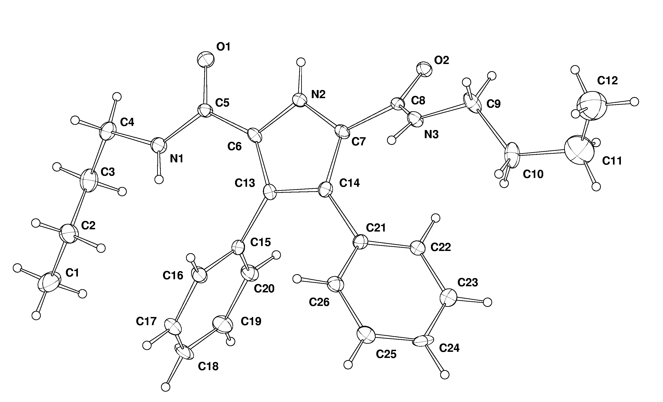

Molecular structure of one of the two chemicallyidential molecules in the asymmeric unit – thermal ellipsoids drawn at the 30% probablity level

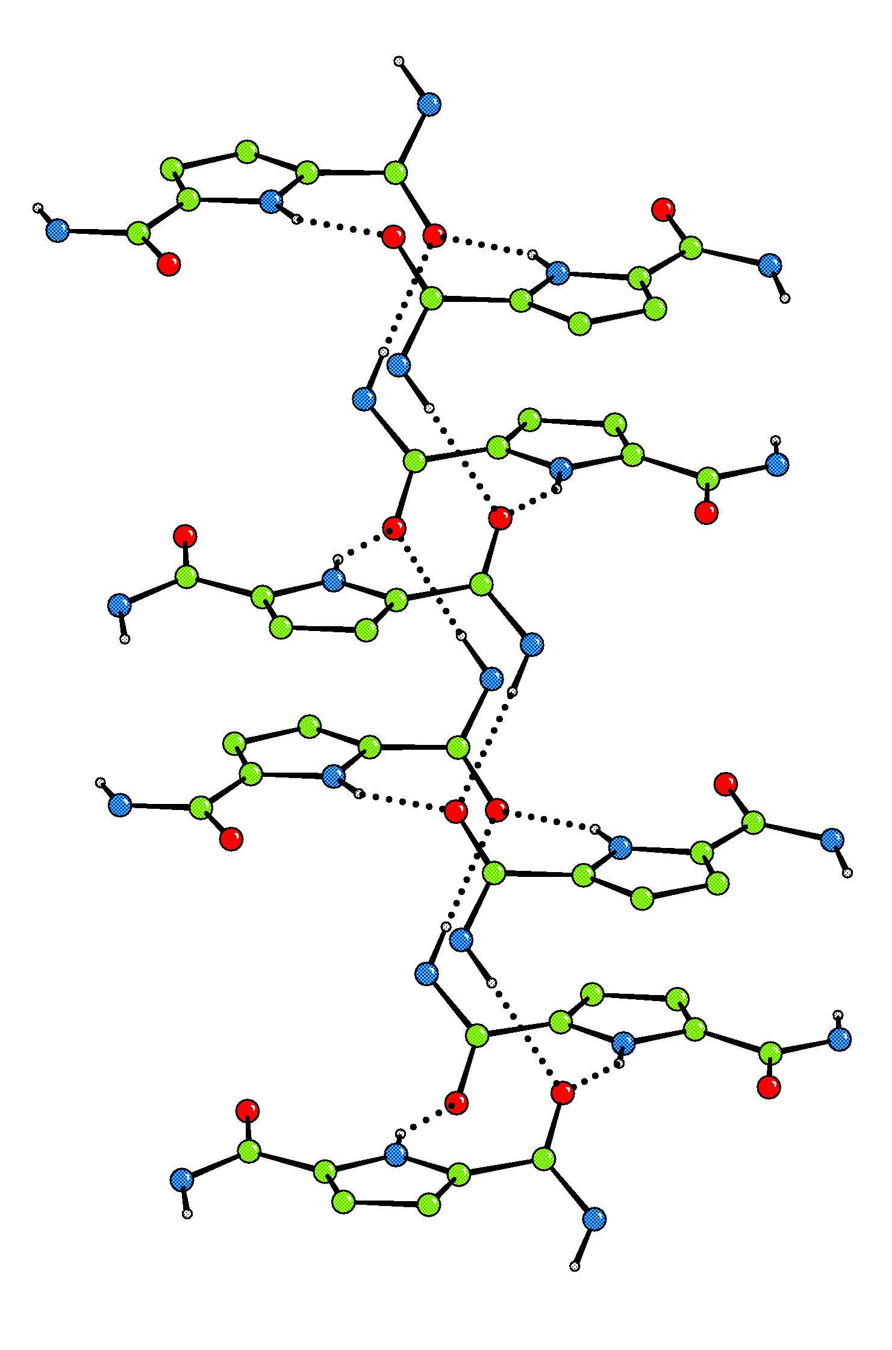

Hydrogen bonded chains that extend down the c axis. Butane and phenyl groups have been omitted for clarity.

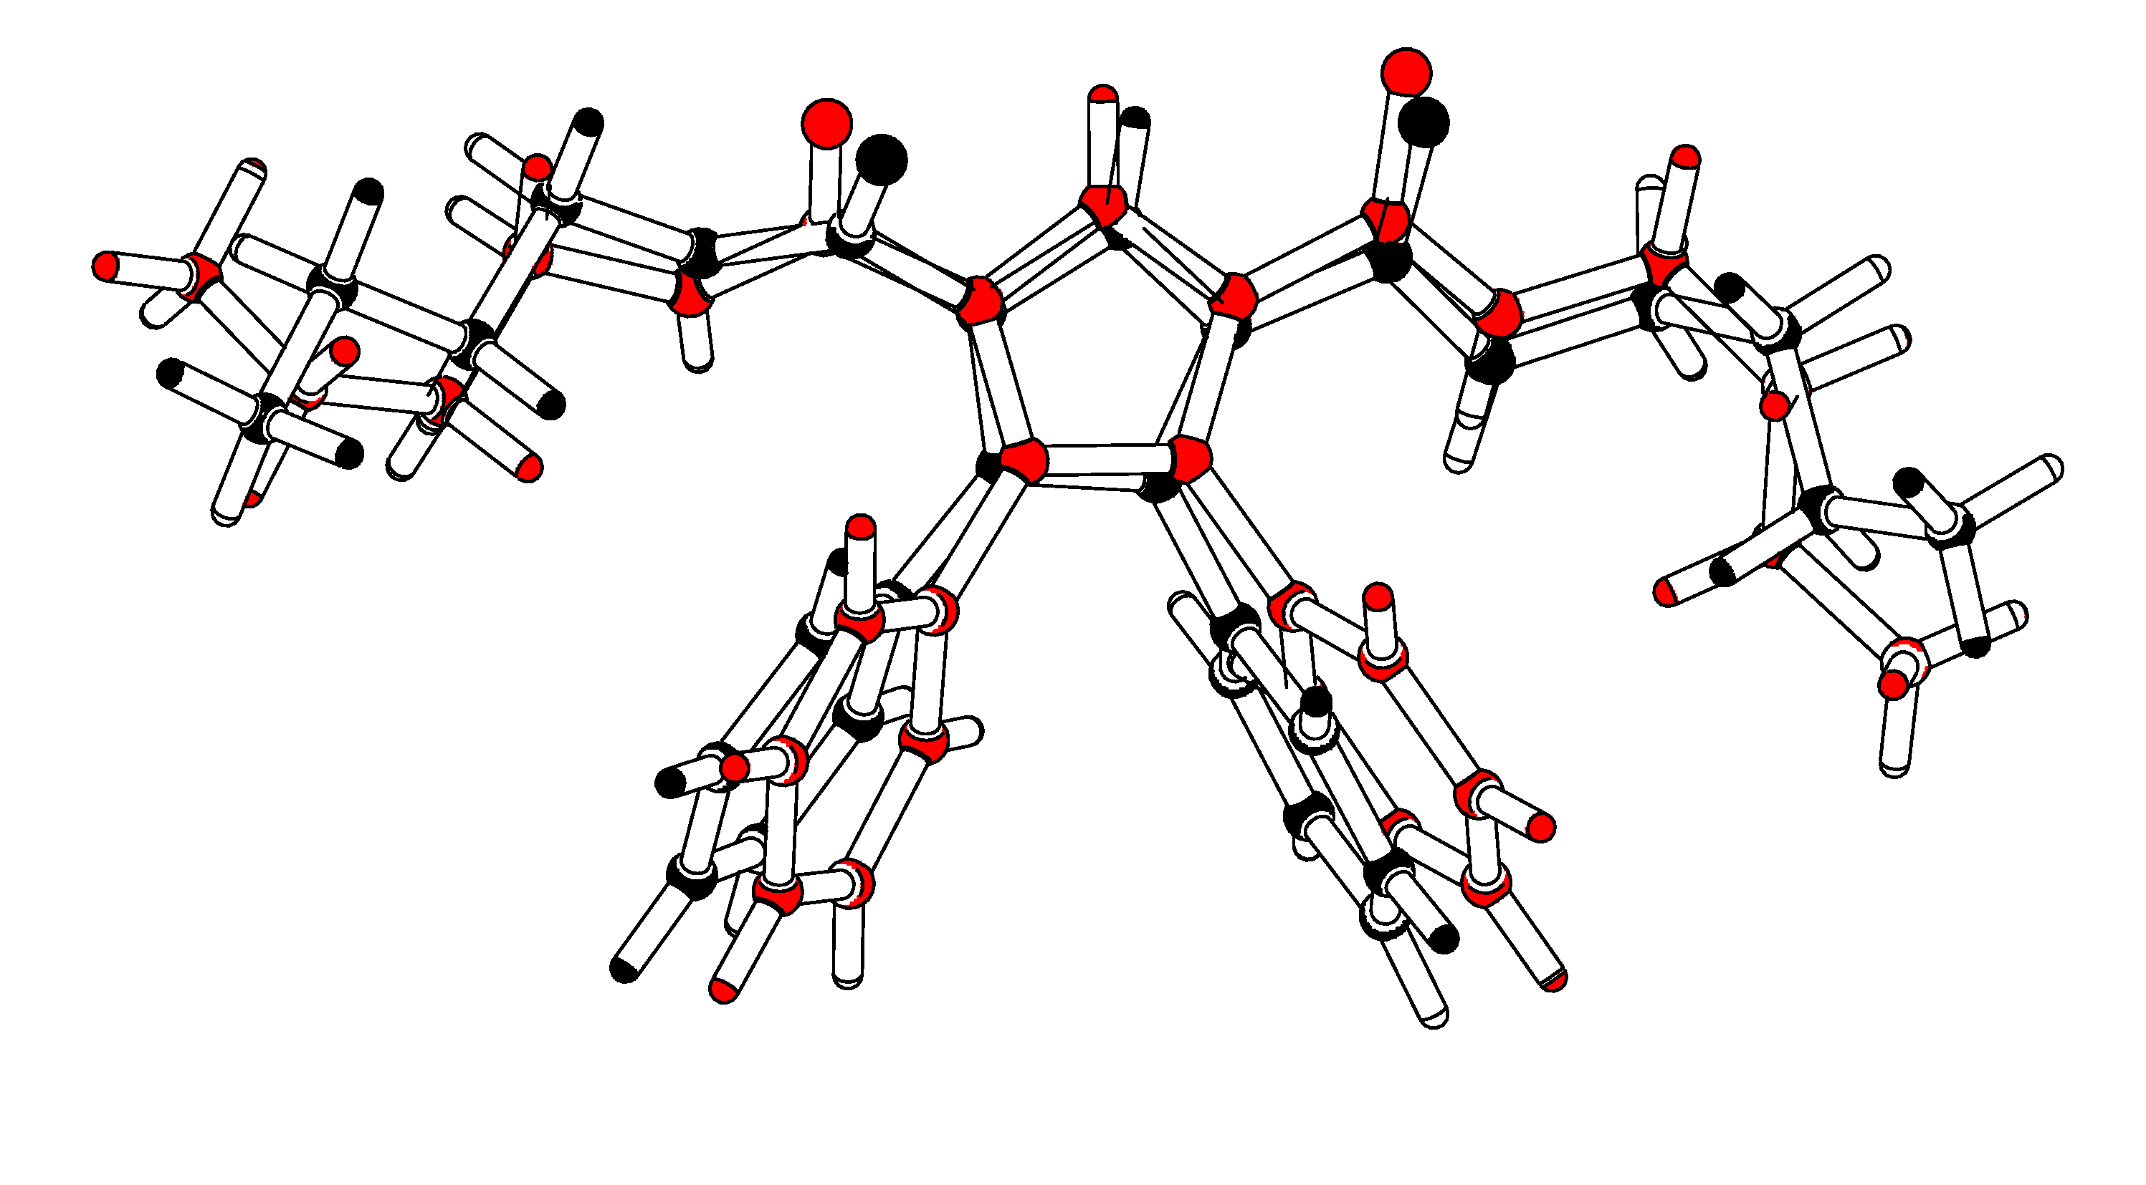

Non-fit of the two independent molecules in the asymmetric unit

