 | University of Southampton · Department of Chemistry  EPSRC National Crystallography Service | 

Table 1. Crystal data and structure refinement.

Identification code 01SOT039
Empirical formula C₁₅H₂₀O₄
Formula weight 264.31
Temperature 150(2) K

Wavelength 0.71073 Å
Crystal system Orthorhombic
Space group P2₁2₁2₁
Unit cell dimensions a = 7.5556(3) Å
b = 8.0446(3) Å
c = 22.9549(8) Å
Volume 1395.24(9) Å³
Z 4
Density (calculated) 1.258 Mg / m³
Absorption coefficient 0.090 mm⁻¹
F(000) 568
Crystal Colourless block
Crystal size 0.25 × 0.10 × 0.08 mm³
θ range for data collection 3.23 − 23.25°
Index ranges −7 ≤ h ≤ 8, −8 ≤ k ≤ 7, −25 ≤ l ≤ 22
Reflections collected 3873
Independent reflections 1860 [R_{int} = 0.0609]
Completeness to θ = 23.25° 97.6 %
Max. and min. transmission 0.9928 and 0.9778
Refinement method Full-matrix least-squares on F²
Data / restraints / parameters 1860 / 0 / 175
Goodness-of-fit on F² 1.033
Final R indices [F² > 2σ(F²)] R1 = 0.0507, wR2 = 0.1298
R indices (all data) R1 = 0.0565, wR2 = 0.1368
Extinction coefficient 0.016(9)
Largest diff. peak and hole 0.192 and −0.239 e Å⁻³

Diffractometer: Nonius KappaCCD area detector (φ scans and ω scans to fill Ewald sphere). Cell determination: DirAx (Duisenberg, A.J.M.(1992). J. Appl. Cryst. 25, 92-96.) Data collection: Collect (Collect: Data collection software, R. Hooft, Nonius B.V., 1998). Data reduction and cell refinement: Denzo (Z. Otwinowski & W. Minor, Methods in Enzymology (1997) Vol. 276: Macromolecular Crystallography, part A, pp. 307−326; C. W. Carter, Jr. & R. M. Sweet, Eds., Academic Press). Absorption correction: SORTAV (R. H. Blessing, Acta Cryst. A51 (1995) 33−37; R. H. Blessing, J. Appl. Cryst. 30 (1997) 421−426). Structure solution: SHELXS97 (G. M. Sheldrick, Acta Cryst. (1990) A46 467−473). Structure refinement: SHELXL97 (G. M. Sheldrick (1997), University of Göttingen, Germany). Graphics: Cameron - A Molecular Graphics Package. (D. M. Watkin, L. Pearce and C. K. Prout, Chemical Crystallography Laboratory, University of Oxford, 1993).

Special details: All hydrogen atoms were placed in idealised positions and refined using a riding model.
Table 2. Atomic coordinates [× 10⁴], equivalent isotropic displacement parameters [Å² × 10³] and site occupancy factors. U_{eq} is defined as one third of the trace of the orthogonalized U^{ij} tensor.

Atom x y z U_{eq} S.o.f.

C1 2736(4) 6913(4) 1043(1) 37(1) 1
C2 1755(4) 6411(4) 554(1) 44(1) 1
C3 1218(4) 7566(5) 145(1) 51(1) 1
C4 1645(4) 9217(4) 211(1) 49(1) 1
C5 2593(4) 9740(4) 694(1) 45(1) 1
C6 3131(4) 8598(4) 1107(1) 40(1) 1
C7 3336(4) 5615(4) 1459(1) 38(1) 1
C8 4678(4) 6064(3) 1928(1) 38(1) 1
C9 6510(4) 6181(4) 1636(1) 39(1) 1
C10 8070(4) 6119(4) 2064(1) 46(1) 1
C11 8556(4) 4280(4) 2065(1) 44(1) 1
C12 8153(4) 3735(4) 1447(1) 39(1) 1
C13 7572(4) 1959(4) 1358(1) 40(1) 1
C14 8904(4) 761(4) 1631(2) 52(1) 1
C15 7308(5) 1569(4) 711(1) 54(1) 1
O1 2827(2) 4173(3) 1420(1) 49(1) 1
O2 4660(3) 4844(3) 2371(1) 46(1) 1
O3 6736(2) 4792(2) 1249(1) 39(1) 1
O4 5913(2) 1663(3) 1655(1) 41(1) 1
Table 3. Bond lengths [Å] and angles [°].

C1−C6 1.396(4)
C1−C2 1.405(4)
C1−C7 1.486(4)
C2−C3 1.380(5)
C3−C4 1.375(5)
C4−C5 1.386(4)
C5−C6 1.381(4)
C7−O1 1.225(4)
C7−C8 1.523(4)
C8−O2 1.413(3)
C8−C9 1.541(4)
C9−O3 1.438(3)
C9−C10 1.536(4)
C10−C11 1.524(4)
C11−C12 1.515(4)
C12−O3 1.441(3)
C12−C13 1.509(4)
C13−O4 1.447(3)
C13−C14 1.528(4)
C13−C15 1.530(4)

C6−C1−C2 118.4(3)
C6−C1−C7 123.3(2)
C2−C1−C7 118.2(3)
C3−C2−C1 120.3(3)
C4−C3−C2 120.5(3)
C3−C4−C5 120.1(3)
C6−C5−C4 120.0(3)
C5−C6−C1 120.7(3)
O1−C7−C1 121.5(3)
O1−C7−C8 119.1(3)
C1−C7−C8 119.4(2)
O2−C8−C7 109.7(2)
O2−C8−C9 111.3(2)
C7−C8−C9 107.7(2)
O3−C9−C10 106.2(2)
O3−C9−C8 109.1(2)
C10−C9−C8 114.2(2)
C11−C10−C9 102.5(2)
C12−C11−C10 103.4(2)
O3−C12−C13 107.4(2)
O3−C12−C11 105.9(2)
C13−C12−C11 117.4(2)
O4−C13−C12 110.1(2)
O4−C13−C14 105.8(2)
C12−C13−C14 110.5(2)
O4−C13−C15 108.1(2)
C12−C13−C15 111.4(2)
C14−C13−C15 110.8(3)
C9−O3−C12 110.6(2)

Table 4. Anisotropic displacement parameters [Å²× 10³]. The anisotropic displacement
factor exponent takes the form: −2π ²[h²a*²U¹¹ + ... + 2 h k a* b* U¹² ].

Atom U¹¹ U²² U³³ U²³ U¹³ U¹²

C1 29(1) 46(2) 36(2) −2(1) 2(1) 0(1)
C2 36(1) 55(2) 41(2) −4(2) −2(1) −3(2)
C3 44(2) 69(2) 41(2) −2(2) −6(1) 1(2)
C4 45(2) 61(2) 43(2) 7(2) 0(1) 6(2)
C5 38(2) 49(2) 49(2) 0(1) 2(1) 4(1)
C6 36(2) 47(2) 37(2) −2(1) −1(1) 4(1)
C7 30(1) 41(2) 41(2) −3(1) 6(1) 1(1)
C8 42(2) 41(2) 31(1) −4(1) −1(1) 5(1)
C9 38(1) 39(2) 39(2) 1(1) −5(1) −4(1)
C10 41(2) 44(2) 53(2) 1(1) −14(1) −3(1)
C11 36(2) 46(2) 51(2) 3(1) −10(1) −4(1)
C12 29(1) 44(2) 44(2) 5(1) 4(1) 2(1)
C13 41(2) 44(2) 35(1) 2(1) 5(1) −1(1)
C14 50(2) 45(2) 60(2) 3(2) 5(1) 6(2)
C15 66(2) 52(2) 44(2) −5(2) 8(2) −3(2)
O1 42(1) 48(1) 58(1) 5(1) −7(1) −6(1)
O2 57(1) 48(1) 34(1) 2(1) 4(1) 8(1)
O3 35(1) 44(1) 36(1) 0(1) −1(1) 3(1)
O4 38(1) 43(1) 41(1) 2(1) 3(1) −5(1)

Table 5. Hydrogen coordinates [× 10⁴] and isotropic displacement parameters [Å² × 10³].

Atom x y z U_{eq} S.o.f.

H2 1459 5273 503 53 1
H3 549 7218 −183 62 1
H4 1290 10000 −76 59 1
H5 2872 10883 741 55 1
H6 3776 8963 1438 48 1
H8 4362 7167 2100 45 1
H9 6576 7235 1406 47 1
H10A 9069 6811 1926 55 1
H10B 7711 6497 2457 55 1
H11A 9823 4120 2158 53 1
H11B 7830 3656 2350 53 1
H12 9219 3947 1200 47 1
H14A 8509 −386 1569 78 1
H14B 8991 981 2050 78 1
H14C 10066 919 1450 78 1
H15A 6929 411 667 81 1
H15B 8425 1739 502 81 1
H15C 6400 2308 550 81 1
H2A 4484 5301 2695 70 1
H4A 5262 2504 1622 61 1

Table 6. Hydrogen bonds [Å and °].

D−H···A d(D−H) d(H···A) d(D···A) ∠(DHA)

O2−H2A...O4^{i} 0.84 1.88 2.708(3) 170.2
O4−H4A...O3 0.84 2.32 2.755(3) 113.0
O4−H4A...O1 0.84 2.32 3.132(3) 161.2
O4−H4A...O2 0.84 2.59 3.185(3) 129.0
Symmetry transformations used to generate equivalent atoms:
(i) −x+1,y+1/2,−z+1/2

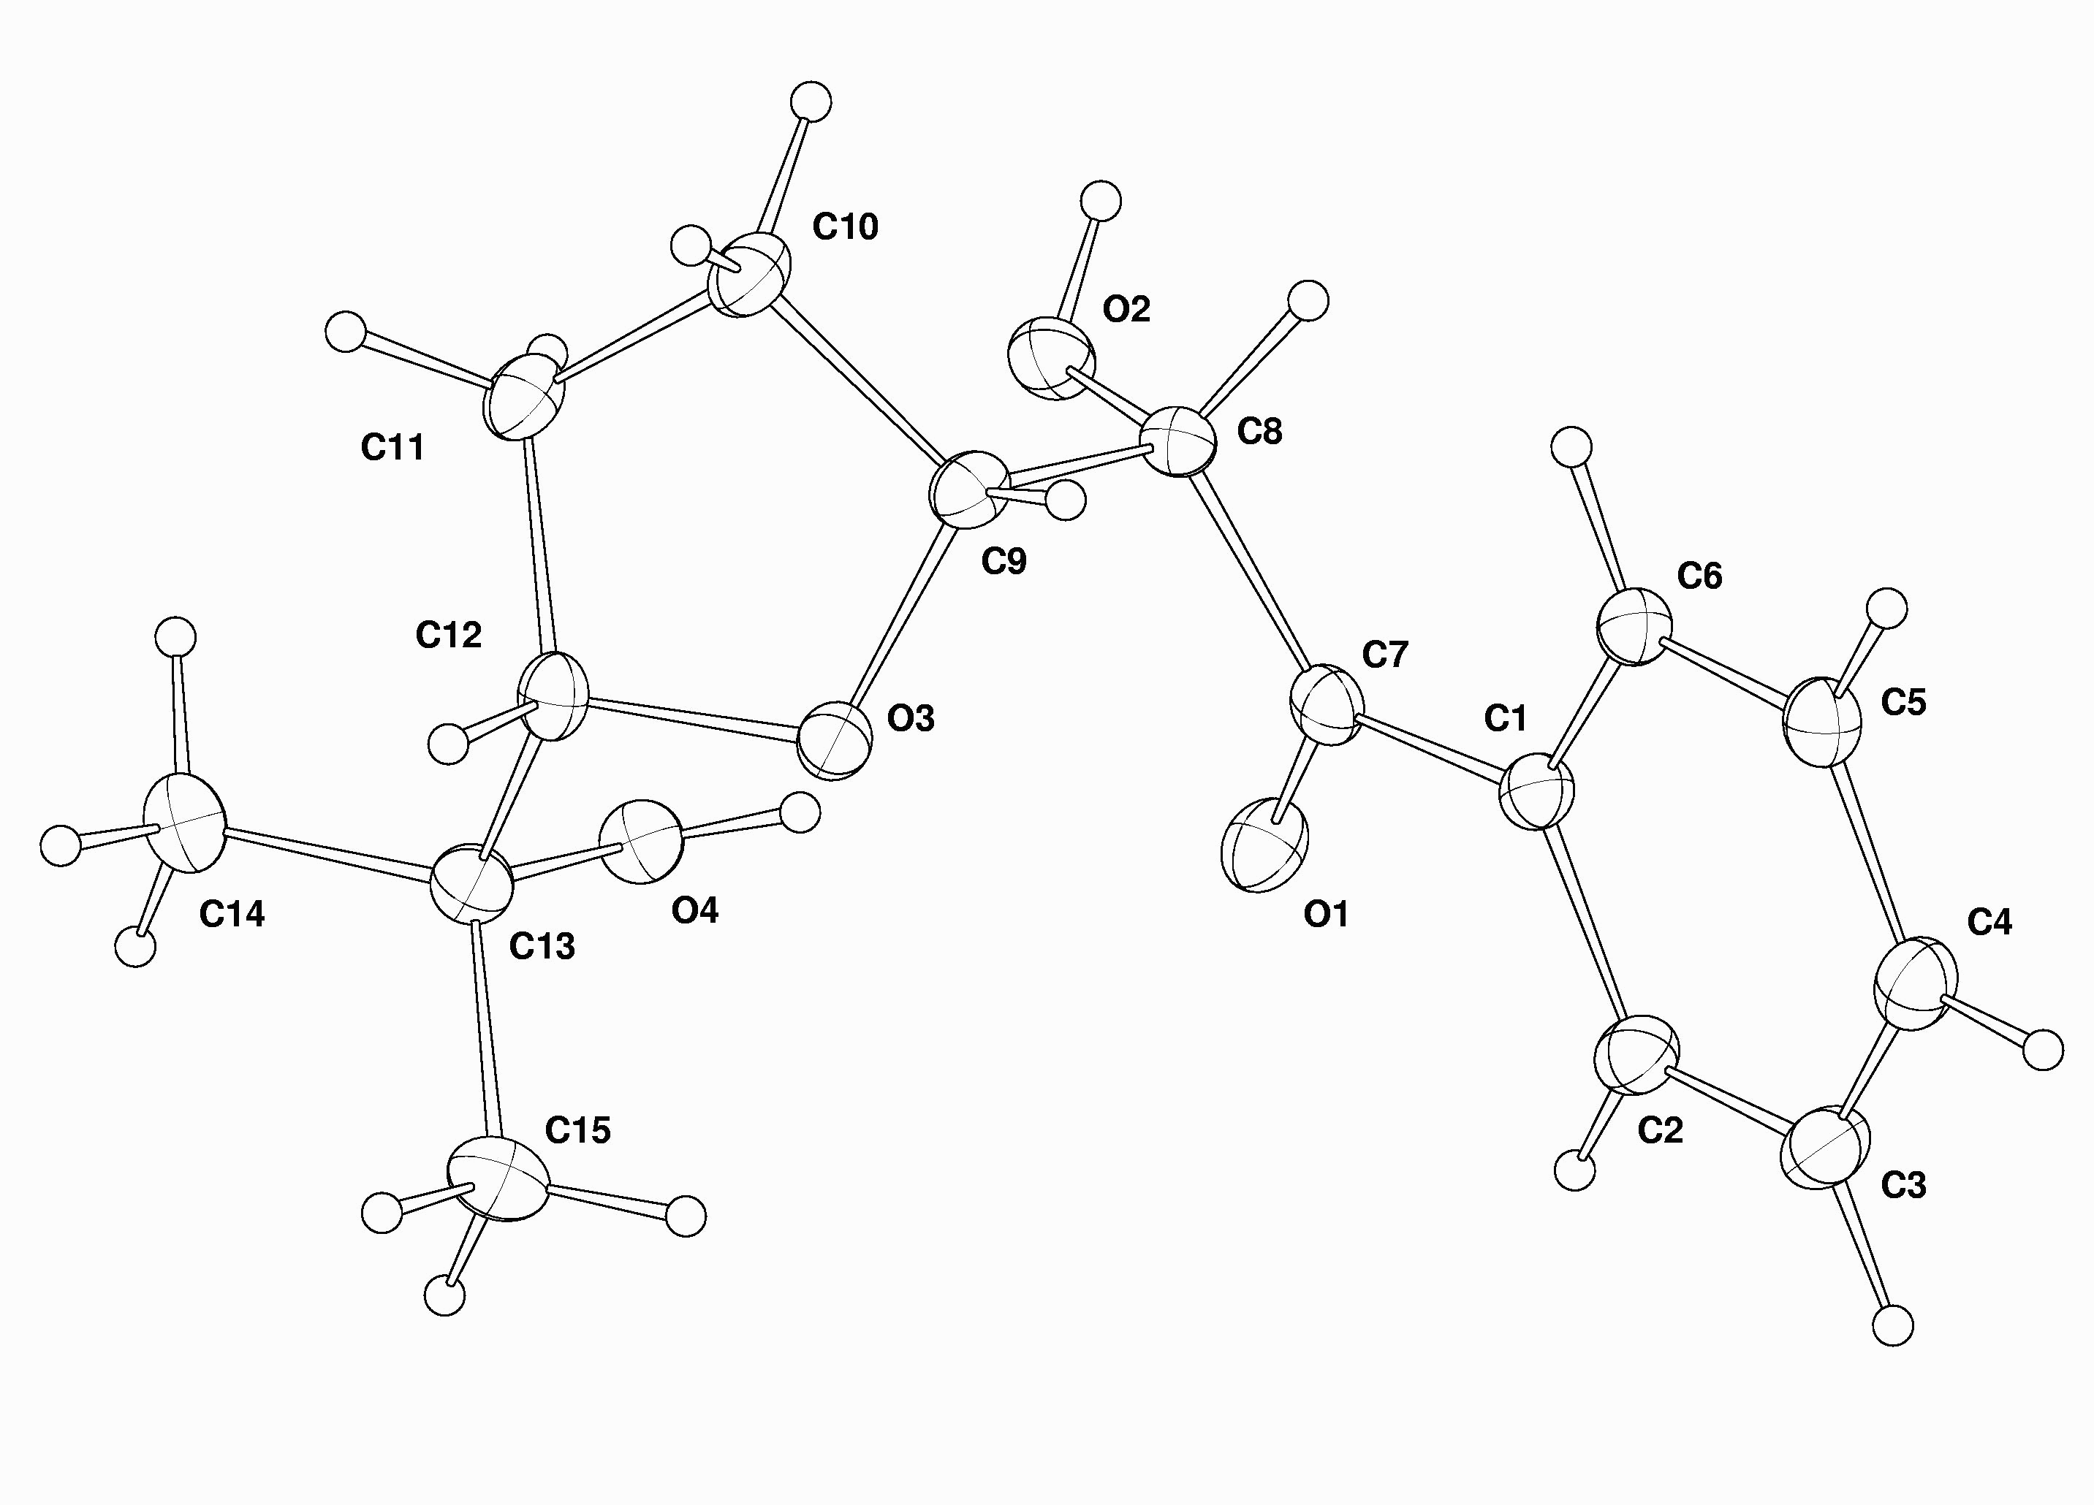

Molecular structure with thermal ellipsoids drawn at the 35 % probablity level

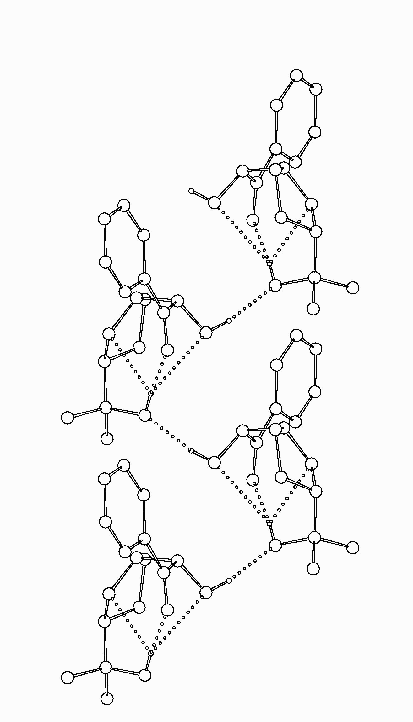

Part of the hydrogen bonded chain that extends along the b axis

